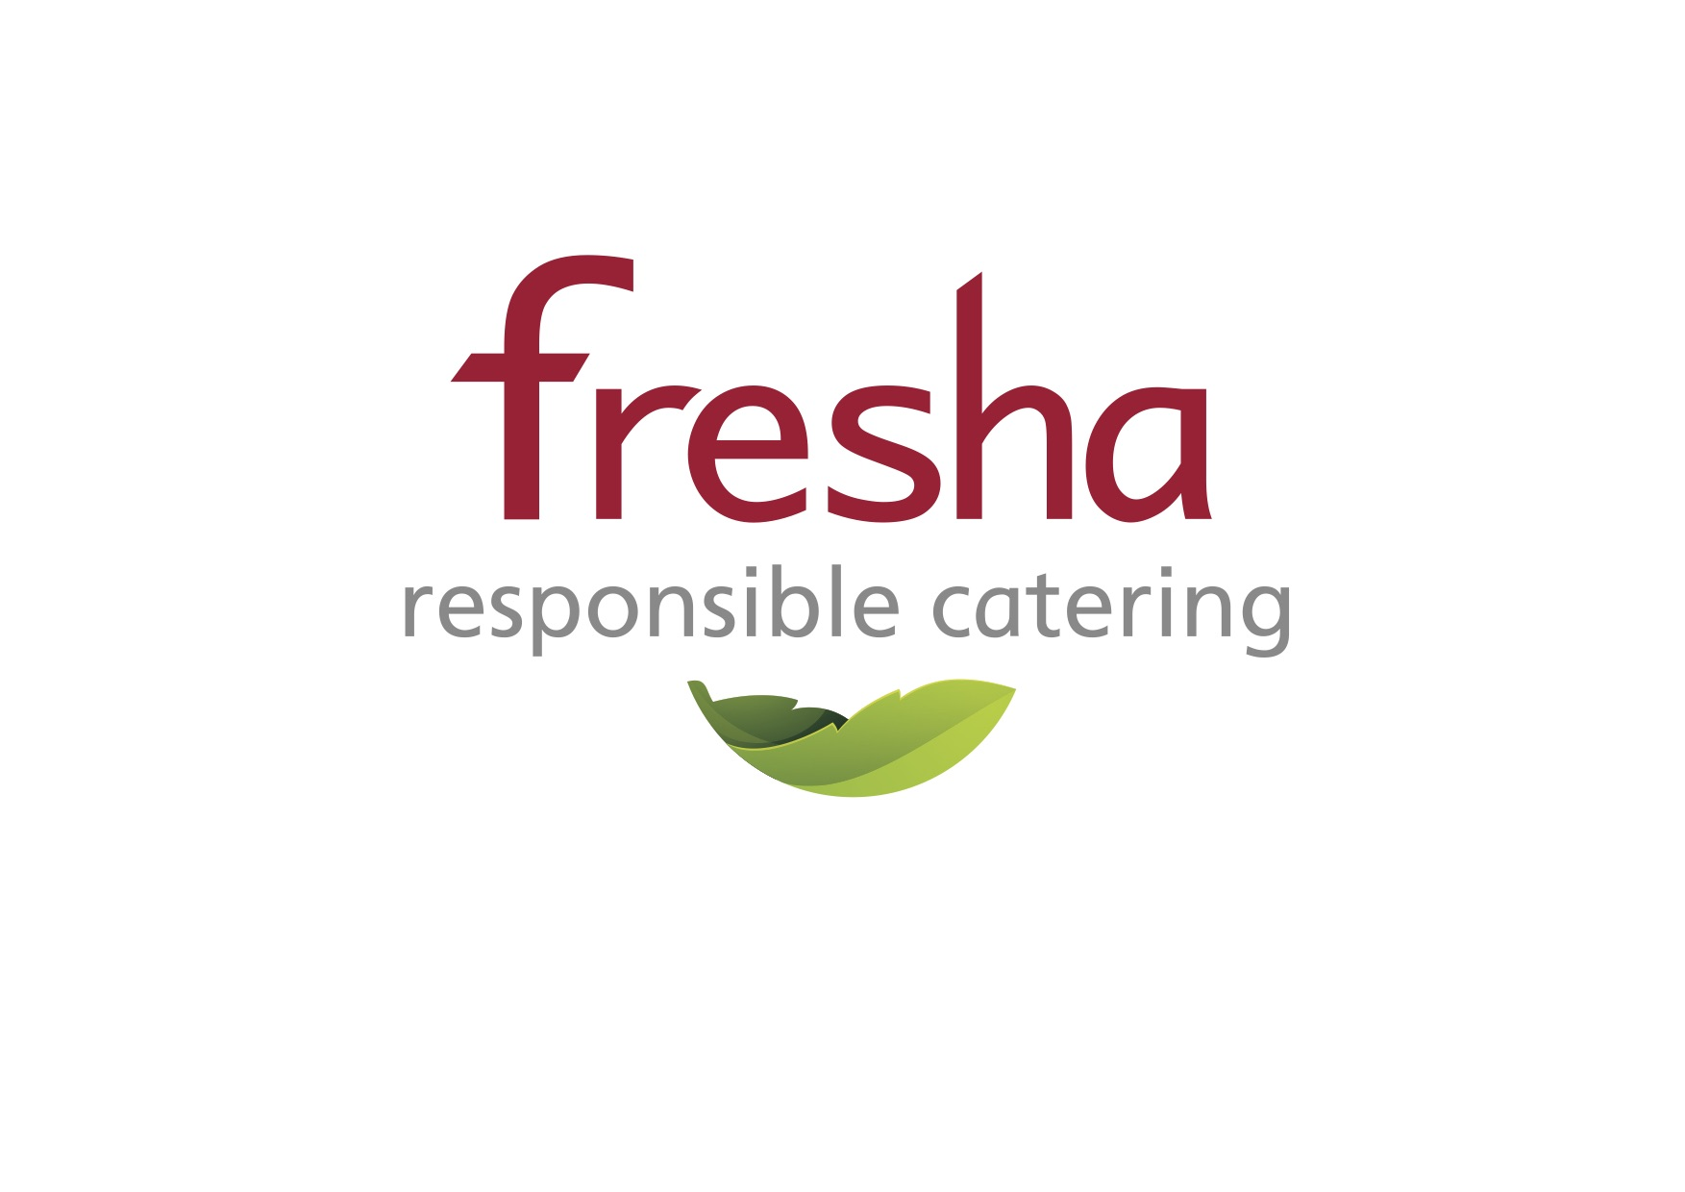
Dear Parent,

We are really pleased we will be providing the school meals for your child (children).

By way of introduction Fresha is a catering company based in Exeter. For the past 10 years, following the positive results of the initiatives begun by Jamie Oliver, we have turned our focus, to specialise in providing freshly prepared, good quality, child friendly food for primary school children in Devon. We are honestly passionate about nutrition and work with a number of research initiatives to improve our knowledge and understanding.

We hope your child(children) love the food we provide, the menus are designed with them in mind. Our team of chefs and a nutritionist work with feedback from parents and school staff to always improve our offering. We are keen to hear what you think so, please feel free to contact us.

It isn’t just about the food and nutrition though, we want to make mealtimes a positive and learning experience for your child (children), so our serving staff will welcome your children, encouraging them to experiment and enjoy their meals, with their friends and clean their plates.

A word about allergens, we take allergies seriously! Our kitchen teams identify individual children with specific dietary and allergen requirements and ensure that these requirements are met.

As well as our desire to provide nutritious food, Fresha has a high regard for the environment, hence our decision to limit our area of operation and source our ingredients locally. We constantly review our operation to make sure we are making the right environmental choices.

I hope I have given you an idea of who we are at Fresha and of where we are coming from in all we do. I could say so much more but I think it best, to point you to our website for more information at https://www.fresha.org.

Please feel free to contact us if you have any questions or concerns.

Kind Regards

Paul Banks
Managing Director

