The following instructions will give you help on to support your children in using Microsoft teams and OneNote.

Start by downloading Microsoft Teams and OneNote, either through the computer/laptop (Google ‘Download Microsoft Teams’) or the app store on your phone / tablet. They both work much better on the app than just open on a web page.

When you open Microsoft Teams, this box will appear. Type in your child’s Microsoft account address in the box and click ‘Sign in’: 

Then, enter your password and click ‘Sign in’:

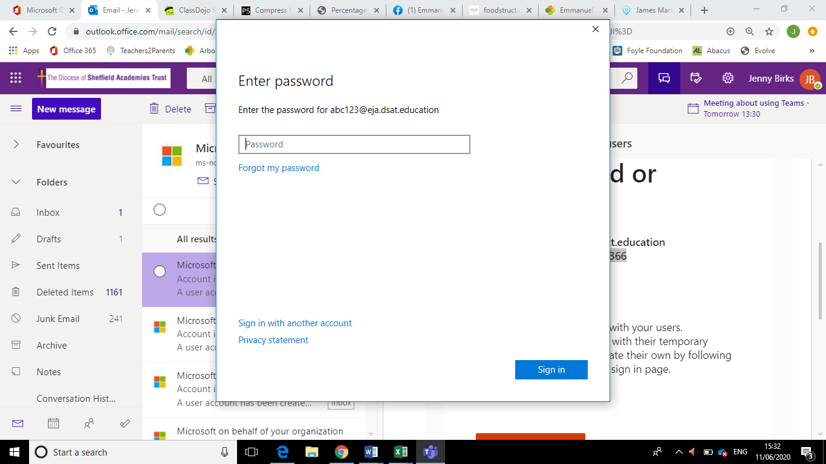

The teams that your child is in will then appear (It will be their class name) Click the team square to enter:

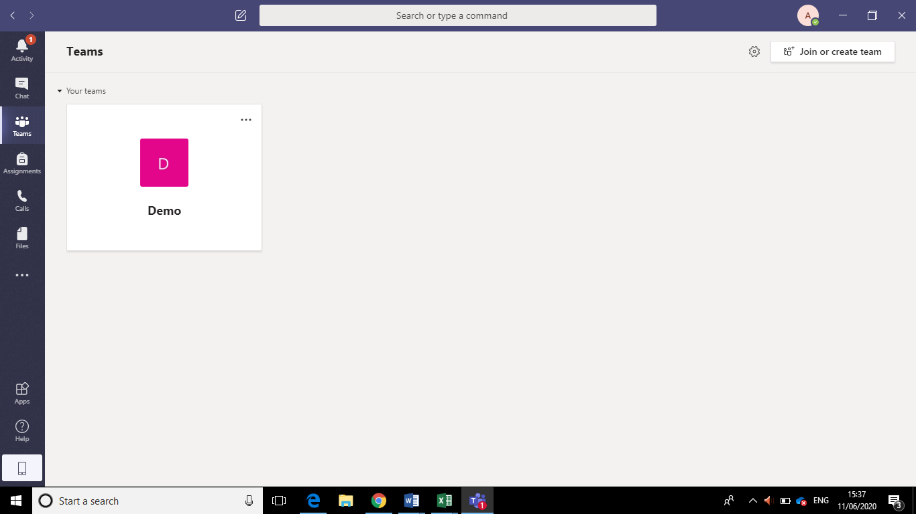

When you are in the team’s general area, it will look something like this. You will probably already have lots on conversations on your ‘post’ page as the children have been using Microsoft teams already. Here, you can post any queries or questions to your teacher or just say hello! Please be aware that everyone can see the conversations here, including your class teacher and head teacher.

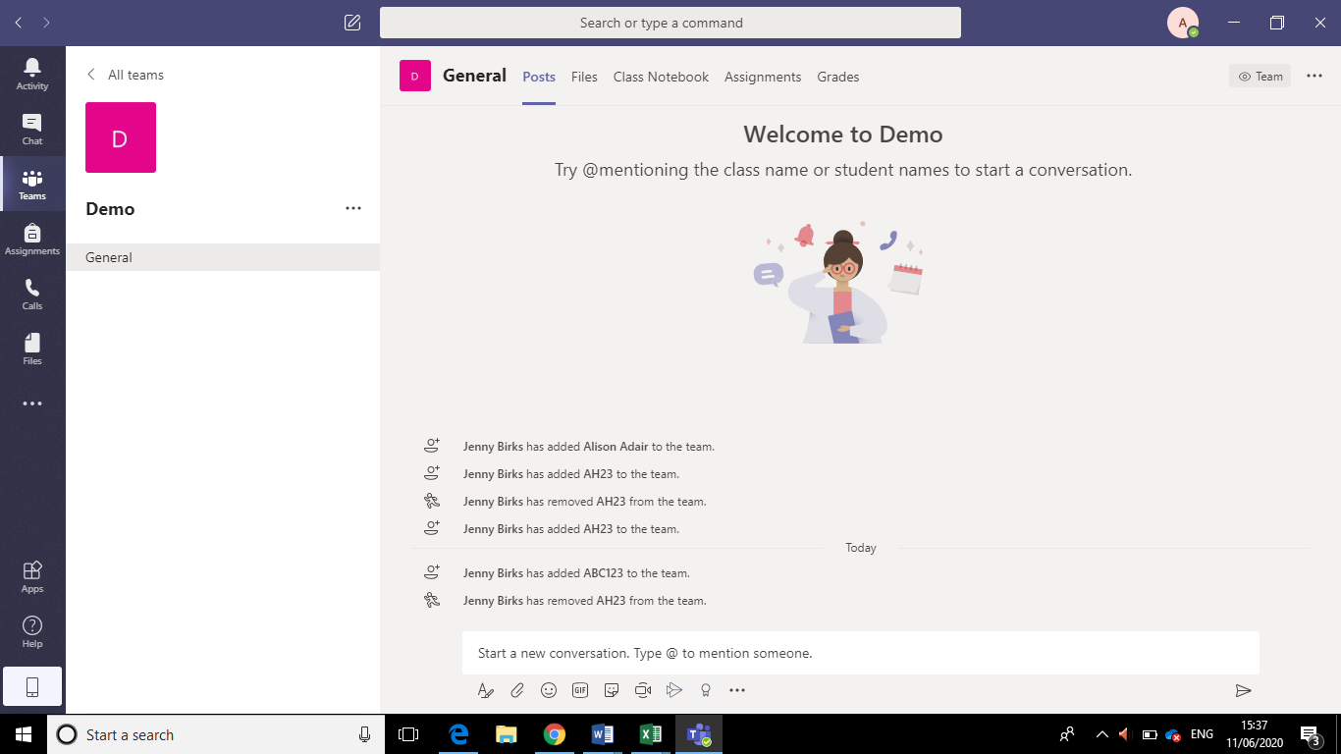

When there is a lesson to join, you will see this. Click the lesson (in a purple box). You may have to scroll up the page to find the purple box.

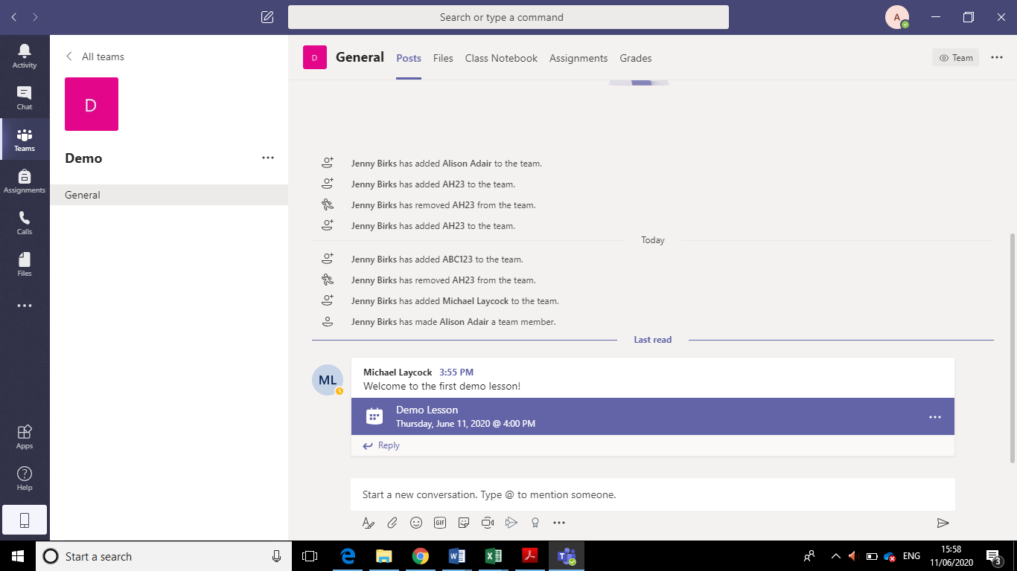



As there may be multiple lessons in a day for your child to attend, you can use your calendar on Teams to help keep track. The calendar button is on the left-hand side. You can click the purple button under the right date at the correct time to join in the live lesson. Your teacher will then allow you into the lesson.



5 minutes before the lesson starts, the button will change and it will now say ‘Join’.

It may take a little while to join, but then you’ll be able to see your teacher’s face!

If you wiggle the mouse, you’ll see this box come up at the bottom of the screen: 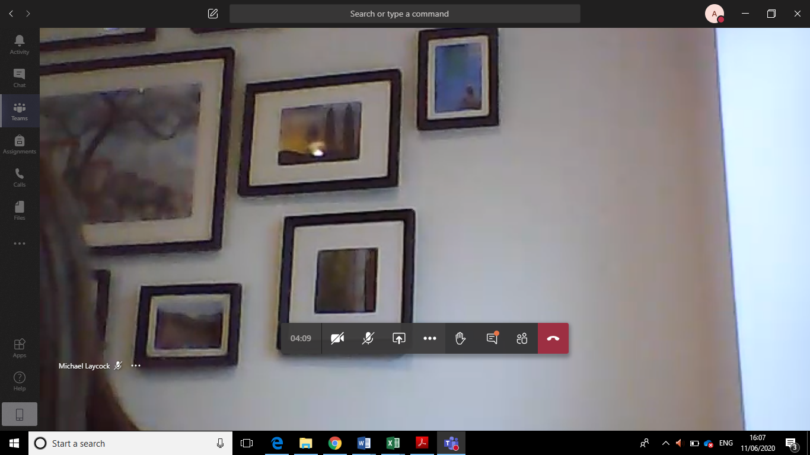



The other buttons you will not need for the lesson.

In the lesson, your teacher will talk to you and/or share their slides. (Just like they do in a normal lesson!) They may not always be able to see or hear everyone as this makes the system lag and it is not always possible with 30 children in one Teams meeting. However, there will be other opportunities for feedback and questions. Don’t forget you can raise your hand to show the teacher you need assistance or you can type a question.

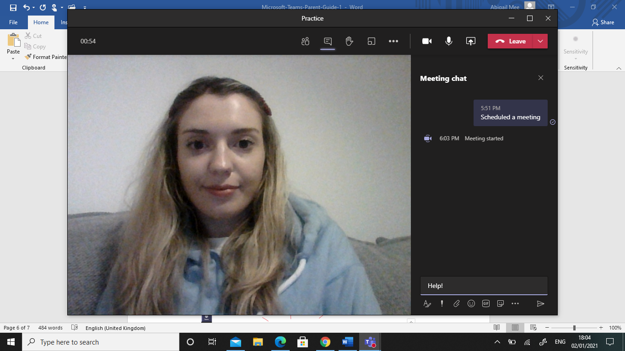

After the live lesson, you will see an ‘Assignment’ has been added to the ‘post’ page. Your child can now complete the worksheet/challenge linked to the learning your teacher has just shown you on the Teams video. You can press ‘view assignment’. You can also press the ‘assignment’ tab on the left to keep track of all the assignments you have completed/need to complete. 



When you press ‘view assessment’ you will see this page below. Under ‘My work’ you will find the OneNote document you need to complete. Click this document.

You can now open this document and complete the work

When you press ‘View Assignment’ you will see the OneNote document your child needs to complete. Click onto it.



You can type directly onto the document. It will automatically save. You will see the work the teacher has set. There may be videos/pictures/questions to look at and complete.



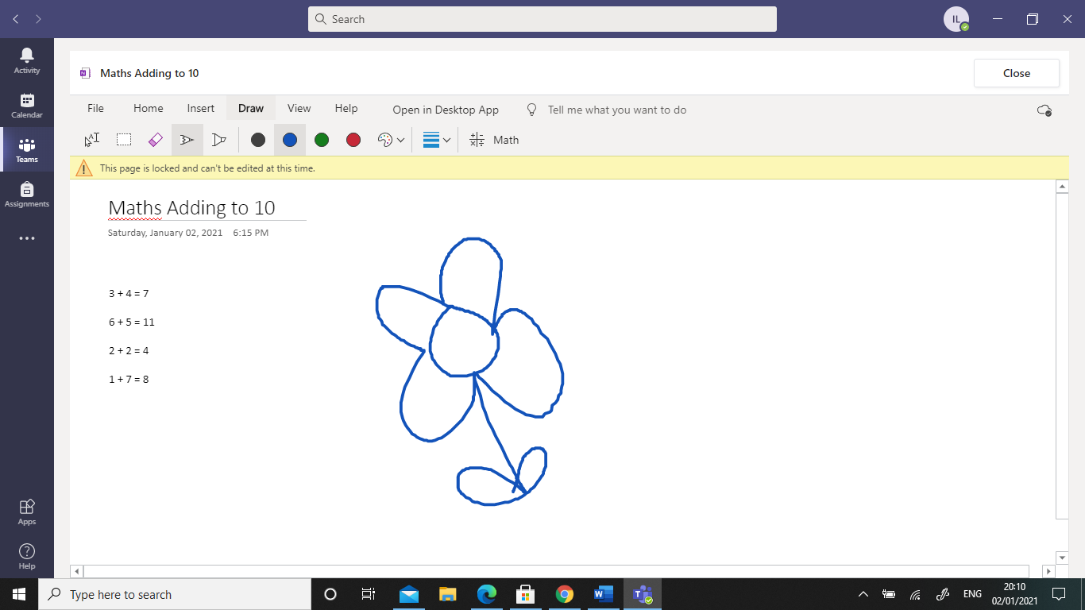

You can click onto the ‘Draw’ tab if you want to use the drawing pen to add onto your work. If you want to go back to typing, press the button circled in red.



You can also add pictures, videos or any other documents onto the OneNote page by pressing insert. Only you and your child’s teacher will be able to see your work.



If you have downloaded the OneNote app, you can press ‘Open in Desktop App’. This does make moving objects around much easier and quicker. When you have done, you can press the ‘Close’ button. You do not need to save. You can edit this document later if needed.





You will then come back to this page. You can now click ‘Turn In’ to send your work to your teacher for marking.



When your child’s teacher has marked their work, a notification will ping. You can also check on your work to see if it has been marked by going onto your ‘Assignment’ tab on the left. You will see the comments the teacher has left and any points they have given to you. You may have an improvement/error you need to correct. If you do, you can click back onto the OneNote document and then press ‘Tune in again’. This will send your work back to the teacher.

And don’t forget, when you’ve finished, make sure you log out to keep yourself safe!