Appendix A

SEF – Three years after joining Ventrus, how does our SEF compare? Do we perceive ourselves to have made solid improvements in any/all of the areas? What ca we do as governors to support and monitor this trajectory from one year to the next?

The fine grading across the terms allows us to track how we are doing in the area Ofsted will judge:

Summer 2017 Overall 2.5 L&M 2.5 T L & A 2.8 PDBW 2.0 EY 2.9
Summer 2018 Overall 2.5 L&M 2.4 T L & A 2.5 PDBW 2.0 EY 2.4

SIP Objective 1 – How does this work with TAs – ie what are we doing to monitor and improve how middle managers draw on the experience of our TAs to enhance work between TA / classroom teachers / middle-managers?

Middles Leadership in the SIP refers to teachers.
It would be useful to identify leadership and development in TAs in the 2018/19 SIP as this is an area that has not been developed as much as it could be. It would perhaps be good for middle leaders to take on more of a role in TA development and also to link support specifically to the development of initiatives.
- All staff more involved in setting priorities
- SIP shared and TAs asked to identify the areas they can be support
- SIP priority linked to appraisal (all staff) to encourage them to play an active role in school development

SIP Objective 2 – Could we be doing more as a governing body, visits etc? Maybe this is something we should discuss collectively at the meeting, but would be good to have Fran’s perspective as HT as to where our strengths and weaknesses are now that the LGB is more settled than it has been for a number of years.

There have been no governor visits this term to support the initiatives within the SIP. Governors have specific strengths and areas of expertise that could benefit the school – we discussed how these could be linked to the SIP priorities when the governors met informally – governors now need to set dates and make sure that the visits happen.

Results Years 3 and 4: Can you explain the apparent discrepancy in Year 4 between ‘on track % for Combined RWM (57%) and prediction for individual subjects 75%-75%-88%? Presumably, it is because different children are below the ‘on track’ threshold in different areas, rather than the same children below ‘on track’ across the board? Any idea why this is? Similar situation for Year 3 (writing at 66% - should we be concerned?). This seems to suggest that year 3/4 remains the areas where we need to focus most of out I@Pol? Will this be more difficult next year when current year 3 and 4 are spread across Sapphire and Diamond?

Reading 12/16 = 75% Writing 12/16 = 75% Maths 14/16 = 88%

The 4 children who are not predicted to achieve EXS in Reading or Writing are not the same as the children not predicted EXS in Maths, hence the lower combined score. For most it is a dip in one area rather than low attainment across the board. This is easier to remedy with interventions and support.

Of the current 16 children in Y4, three (possibly 4) are leaving at the end of theyear. One to return abroad, one to attend specialist provision and one (possibly 2) moving house out of the area. From the 12 children who will join Y5 2/3 are on track (66%) FOR Reading, Writing & Maths EXS.

When tracking the current &4 with data in KS1 and EYFS attainment has always been low.
Identified issues in 2016/17 – staffing difficulties and under performance – addressed by L & M to result the situation. 2017/18 inconsistencies in teaching due to staff turnover.

SCHOOL POPULATION |  | Year 4
 | Number of pupils | 16
 | % girls | 62.5
 | % FSM | 25.0
 | % EAL | 31.3
 | % SEN support | 12.5
 | % SEN statement/EHCP | 6.3
 | % SEN | 18.8
 | Number of CLA | 0
KS1 2016
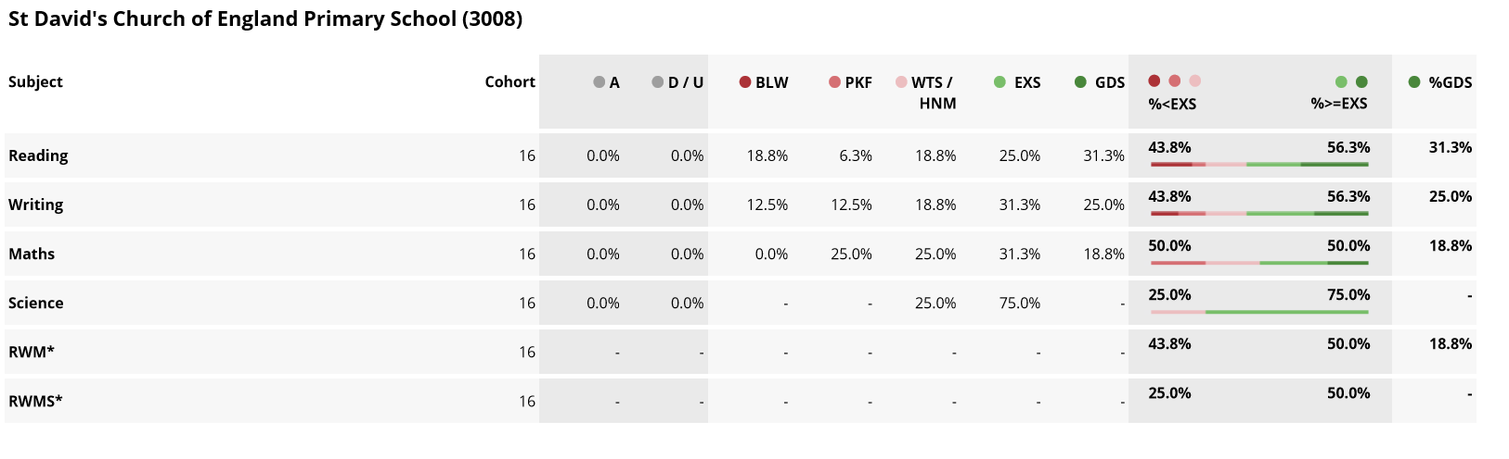

EYFS 2014

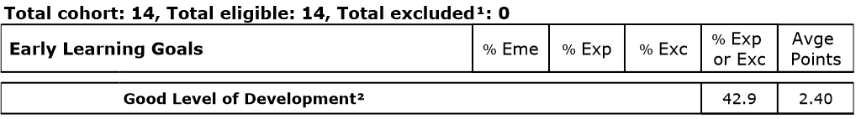

Year 3 have a different profile – their KS1 results were good. There are only 12 children in the cohort – one is leaving at the end of the year (EAL). Of the remaining 11 children, 4 are not currently on track for EXS in one area – they are assessed as being slightly below – interventions are in place and it is anticipated that by the end of the academic year these children will be on track.

