 | Addition To be taught alongside each other Subtraction |  | Multiplication To be taught alongside each other Division
Y3 | Children will continue to use empty number lines with increasingly larger numbers and will begin to use informal methods (jottings) to support, record and explain partial mental methods, building on existing mental strategies.  Counting on  Count on from the largest number irrespective of the order of the calculation. Bridge through tens and begin to bridge through 100’s.  E.g. 38 + 86 = 124  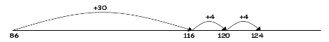  Compensation (for near multiples of 10) e.g. 49p + 73p = 122p  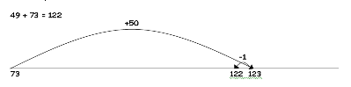  Expanded informal method using place value (Introduce practically. Encourage children to use when the calculation can’t be done mentally. Model first with simpler numbers which they can solve mentally).  Model expanded horizontal partitioning with Base 10.  67 = 60 + 7  +24 20 + 4  91 = 80 + 11  243 = 200 + 40 + 3  +435 400 + 30 + 5  678 = 600 + 70 + 8 | Children will continue to use empty number lines with increasingly large numbers and will begin to use informal methods (jottings) to support, record and explain partial mental methods, building on existing mental strategies.  Counting back  Subtracting the tens in one jump and the units in one jump (focus on efficiency… e.g. challenge children to solve subtraction calculations in two steps) 147 -23 = 147 – 20 = 127 127 – 3 = 124  Bridging through ten can help children become more efficient.  e.g. 147 – 63  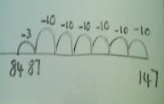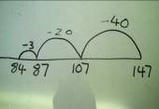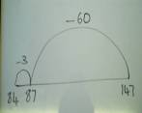  Counting on Use Finding the difference ITP between two numbers by counting on. Relate to every day contexts such as age, height, length etc.  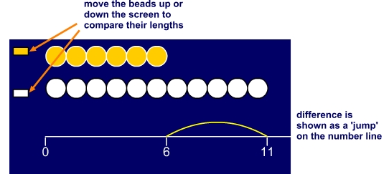  Where the numbers involved in the calculation are close together or near to multiples of 10, 100 etc. counting on using a number line should be used, alongside resources like bead bars. 102 – 89 = 13  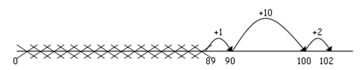  Compensation (for near multiples of 10) 63 – 8 = 55  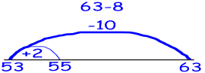  Expanded informal method using place value  67 = 60 + 7  -24 - 20 + 4  43 = 40 + 3  Develop into 3 digit – 2 digit numbers modelling with Base 10. Partition 3 digit numbers into ways that are helpful for the subtraction. E.g. 325 – 58 = 325 – 25 - 25 – 5 – 3 = 267  Or 325 – 58 = 267 so 325 becomes 200 + 110 + 15  - 50 - 8  200 + 60 + 7 | Children will continue to use: Repeated addition  6 multiplied by 4 = 6 x 4 = 6 ‘four times’  4 times 6 is 6 + 6 + 6 + 6 = 24 or 4 lots of 6  Children should use number lines or bead bars to support.  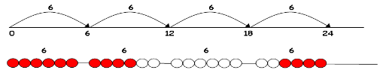  Arrays Increasingly use arrays to make links between x and ÷.  Children should model a multiplication calculation using an array. This knowledge will support the development of the grid method.  4 x 9 = 36 36÷ 9 = 4 36 ÷ 4 = 9  Important for teachers to be consistent. Either seen as a row of 9, 4 times (9 x 4)... or a column of 4, 9 times (4 x 9). Both are correct  Moving towards 2 digit x 1 digit using place value.  90 x 4 = 40 x 9 = 360 360 ÷ 9 = 40 360 ÷ 4 = 90  Derive facts from unknown facts  Use number line to show known multiplication facts and then derive unknown facts. E.g. if you know 5 x 10 = 50. Count back 5 to derive 5 x 9 etc. 5 x 5 will be half of 5 x 10 etc... Relate to other ‘tables’.  0 5 10 25 30 45 50  Also Partition an array to show how to derive an unknown fact from a known fact e.g. use knowledge of 2 and 5 times tables to work out multiples of 7, e.g. 7 x 3 = 5 x 3 + 2 x 3  15 + 6 = 21  Scaling  Use Base 10 equipment to show 10 times bigger / smaller. Model the enlargement. E.g to show why 6 x 3 helps in solving 60 x3.  Find a ribbon that is 4 times as long as the blue ribbon r = b x 4  Using symbols to stand for unknown numbers to complete equations using inverse operations  x 5 = 20 3 x = 18 x = 32  Partitioning (2 digit x 1 digit numbers)  38 x 5 = (30 x 5) + (8 x 5) = 150 + 40 = 190 | Ensure that the emphasis in Y3 is on grouping rather than sharing, except when using fractions as this is sharing.  Children will continue to use:  Number lines and known multiplication facts to solve division following on from repeated addition.  Use number lines and known multiplications to solve divisions incl. with remainders.  Move into chunking (grouping) using these steps. Encourage children to be as efficient as possible.  23 ÷ 5 = 4 r3  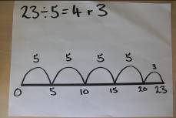  Moving towards more efficient approaches, using known facts.  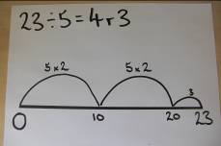  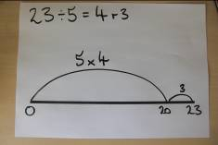  Using symbols to stand for unknown numbers to complete equations using inverse operations (2 digit ÷ 1 digit numbers)  26 ÷ 2 = 24 ÷ = 12 ÷ 10 = 8  Find unit fractions of numbers and quantities  Start to relate fractions to division in context:  E.g. A cake recipe for 8 people uses 500g of flour. How much flour would I need to make a cake for 4 people?  What is ½ ⅓ ¼ ⅙ of 12 litres or ¼ of 20 kg ?
Y4 | Expanded informal method  67 = 60 + 7 2000 +300 +20 +7  +24 20 + 4 +500 +40 +2  91 = 80 + 11 2000 +800 +60 +9 = 2869  Model expanded horizontal partitioning with Base 10 leading to compact vertical method working from left to right, then from right to left.  67 67  +24 + 24  80 11  11 80  91 91  Moving quickly into 3 or 4 digit numbers for calculations that are hard to solve mentally.  625 + 324 900 40 9 949 625 + 324 9 40 900 949 2327 + 542 2000 800 60 9 2869 2327 + 542 9 60 800 2000 2869  Model how solving an addition on an empty number line increasingly becomes less efficient as the complexity and size of numbers increases.  Moving into compact method  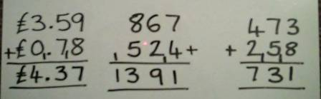  Compensation  Continue to teach compensation method where children round and adjust to the nearest 10 / 100, especially in the context of money.  £4.99 + £6.99 = £5.00 – 1p + £7.00 – 1p = £12.00 – 2p = £11.98  Using similar methods, children will:  - add several numbers with different numbers of digits;  - begin to add two or more three-digit sums of money, with or without adjustment from the pence to the pounds;  - know that the decimal points should line up under each other, particularly when adding or subtracting mixed amounts, e.g. £3.59 + 78p. | Difference by counting on (See Y3) For numbers close together  E.g. 102 – 89 = 13  Including measures e.g.  754ml – 690ml or 1275g – 786g or £3.00 - £2.68  Counting back and Compensation When appropriate (using number lines) bridging through 10, 100 and 1000 and rounding and adjusting (compensating) e.g. 42p – 5p or 193 litres – 18 litres or £823 – £32 or 706mins – 28mins or 307cm – 111cm or 1006km - 9km  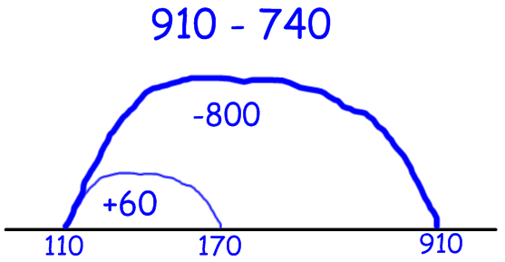  Expanded horizontal (including 4 digit numbers) using base 10  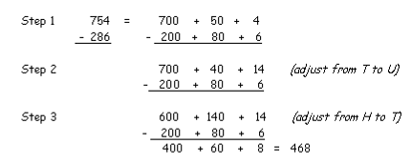  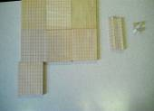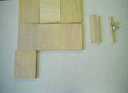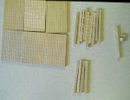  754 = 700 + 50 + 4 = 700 + 40 + 14 = 600 + 140 + 14  - 200 80 6  400 60 8  Children should:  - be able to subtract numbers with different numbers of digits;  - begin to find the difference between two three-digit sums of money, with or without ‘adjustment’ from the pence to the pounds;  - solve with increasing efficiency using only two steps | 2 and 3 digit x 1 digit numbers. Include X 0 and X 1  Partitioning using place value and the distributive law  38 x 5 = (30 x 5) + (8 x 5)  = 150 + 40  = 190  Children will continue to use arrays where appropriate leading into the grid method of multiplication.  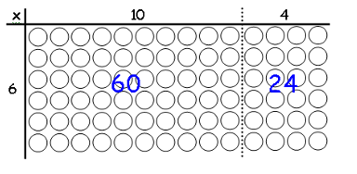  (10 x 6) + (4 x 6)  60 + 24  = 84  Grid method  (Short multiplication – multiplication by a single digit)  Children can approximate first  23 x 8 is approximately 25 x 8 = 200  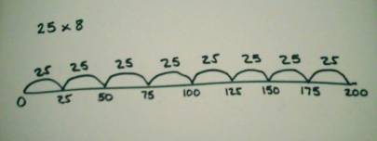  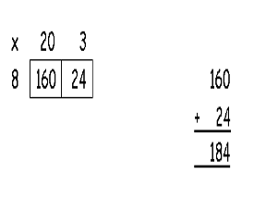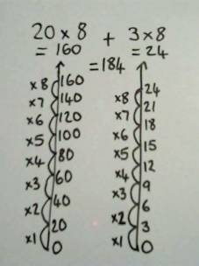  23  X 8  24 (3 x 8)  + 160 (20 x 8)  184  Recognise and use factor pairs.  21 x 8 = 7 x 3 x 2 x 4 = 168  Multiply 3 single digits together e.g. 3 x 4 x 5 | 2 and 3 digit ÷ 1 digit numbers. Include ÷ 0 and ÷ 1  Number lines and known multiplication facts to solve division  Children will continue to develop their use of number lines and known multiplication facts to solve division (using known multiples of the divisor). Initially, these should be multiples of 10s, 5s, 2s and 1s – numbers with which the children are more familiar, moving onto 3’s, 4’s and 8’s.  Short division (2 digit ÷ 1 digit numbers)  Illustrate using horizontal and vertical bead bar and number line to make link between vertical column method. Expanded written method with common multiple, leading to division of other multiples.  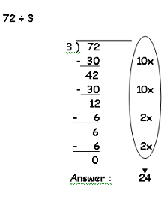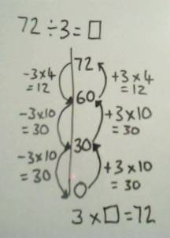  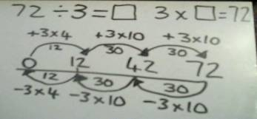  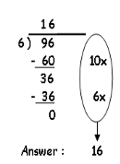  Using knowledge of place value, known facts and fractions. 360 ÷ 6 = 60 6 x 10 x 6 or 6 x 6 x 10 or 6 x 60 = 360  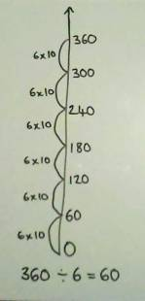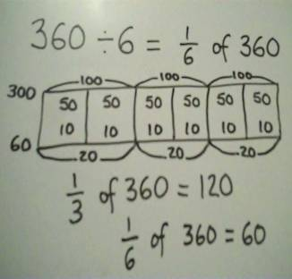  Children need to make sensible decisions about rounding up or down after division accordingly. Any remainders should be shown as integers, e.g. 44 ÷ 3 = 14 remainder 2 or 14 r 2.

