Respect, Trust, Friendship, Compassion, Justice and Forgiveness
We believe that Home Learning is really important. Home Learning doesn't just have to consist of Maths and English work from school. Home Learning is about spending time together as a family, enjoying different experiences and creating memories. Learning can take place EVERYWHERE. Please try to complete as many of these home learning tasks as you can and bring them into school to share with your teacher and class!
Maths:
EYFS- Encourage children to recognise numbers 0-20 and to count forwards and backwards from any given number. Encourage children to name 2D shapes and some properties ie side, corner
Year 1 – Encourage children to recognise numbers 0-100 andto count forwards and backwards from any number (0-100). Encourage children to recall number bonds to 10 ie 2+8, 3+7, 4+6
Reading:
Sharing book: Please read your child’s ‘sharing book’ to them daily and record in their reading diary. Please return to school daily so that your child can change this book. This book encourages language development and a love of books..
Little Wandle Reading Book: Your child will bring home the book they have been reading in school each Friday for a ‘show off’ read to you at home. Please return this book to school on the following Monday.
Spelling: Please practice the following spellings at home.
EYFS- is, I, the, go, no, into, she, push, he, of, put, push, pull, we, me, be , he.
Year 1- the, put* pull* full* push* to, into, I, no, go, of, he, she, we, me, be ,was, you, they, all, are, my, by, sure, pure, said, have, like, so, do, some, come, love, were, there, little, one ,when, out, what, says, here ,today
Science | Can you spot signs of Spring?  Go on a nature walk! What do you notice about the trees and plants? | 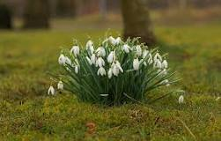
Understanding the World | Can you find pictures of when you were a baby?  How did your adults look after you when you were little?
Art | Can you draw a picture of a flower or plant?  What colours can you see? | 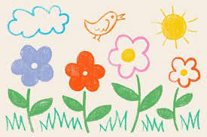
RE | What occasions do you celebrate at home?  How do you celebrate?

