 | Addition To be taught alongside each other Subtraction |  | Multiplication To be taught alongside each other Division
Y5 | Children should be taught to add more than four digits,  including decimals  Number lines using efficient counting on  4526ml + 3807ml = 8333ml = 8.333 litres  + 1000 + 1000 + 1000 + 500 + 300 + 4 +3  4526 5526 6526 7526 8026 8326 8330 8333 ml  4526ml + 3000ml + 800ml + 7 ml  Compact Method  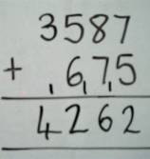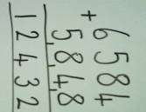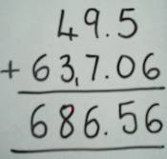  Compensation Children need to round and adjust to the nearest 10 / 100/1000 especially in the context of money.  £4.95 + £6.80 + £9.14 =  £5.00 – 5p + £7.00 – 20p + £9.00 + 14p =  £5.00 + £7.00 + £9.00 = £21.00  + 14p – 25p = - 11p  = £21.00 – 11p = £ 20.89  Using similar methods, children will:  - add several numbers with different numbers of digits;  - begin to add two or more decimal fractions with up to three digits and the same number of decimal places;  - know that decimal points should line up under each other, particularly when adding or subtracting mixed amounts, e.g. 3.2 m – 280 cm. | Children should be taught to subtract using more than four digits, including decimals  Number lines and Difference ‘Find the difference by counting up’  E.g. 754 - 586 or 21.4cm – 18.6cm = 18.6cm + = 21.4cm  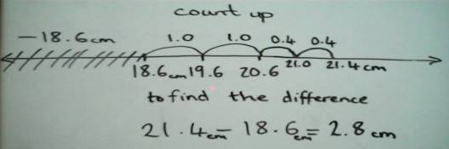  Where the numbers involved in the calculation are close together or near to multiples of 10, 100 etc counting on using a number line should be used. E.g. 1209 – 388 = 821  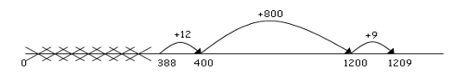  Partitioning and decomposition (only when secure using number lines)  600 140 14  700+ 50+ 4  - 200+ 80+ 6  400+ 60+ 8 = 468  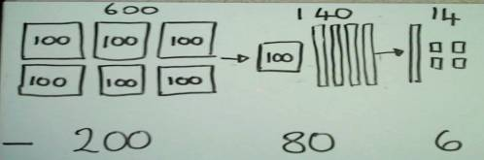  Decomposition (Only when secure with the expanded form)  3 12 2 16 3000 1200 20 16  4 2 3 6 4000 200 30 6  - 2 8 2 7 - 2000 800 20 7  = 1 4 0 9 1000 400 0 9  Moving onto decimals when secure  Children should:  - be able to subtract numbers with different numbers of digits;  - begin to find the difference between two decimal fractions with up to three digits and the same number of decimal places;  - know that decimal points should line up under each other  - encourage children to record in the most efficient way: just two steps. | Grid method (See Y4 to link grid method with arrays)  Children should calculate TOxO mentally, with jottings (not grid).  3 and 4 digit x 1 digit numbers  Short multiplication (multiplication by a single digit)  Children will approximate first  346 x 9 is approximately 350 x 10 = 3500  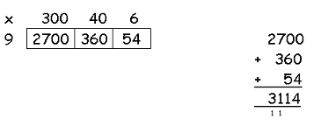  Long multiplication (multiplication by more than a single digit)  Children will approximate first  72 x 38 is approximately 70 x 40 = 2800  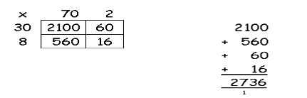  Expanded column method (most able children)  Children should multiply decimals with one decimal place by a single digit number, approximating first. They should know that the decimal points line up under each other.  4.9 x 3 is approximately 5 x 3 = 15  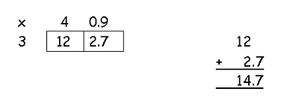  Factorise to multiply by larger numbers eg. 35x14  35x (2x7)  (35x2) x7  70x7= 490 | Children should calculate TO ÷ O mentally, with jottings, using knowledge of known facts.  Short division HTO ÷ O Children can start to subtract larger multiples of the divisor, by x multiples of 10  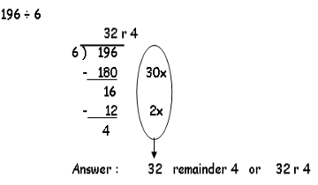  Solve division by chunking into known multiples of the divisor and illustrate on a vertical number line.  Any remainders should be shown as integers, then as fractions, i.e. if the children were dividing 32 by 10, the answer should be shown as 3 ²/₁₀ (which could then be written as 3 ¹/₅ in it’s lowest terms).  Children need to make sensible decisions about rounding up or down after division, according to the context.  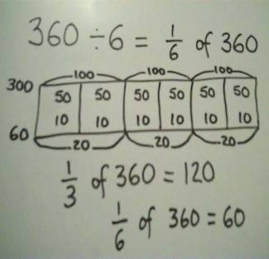 (See Y4)  2000 ÷ 400  2000 ÷ 4  1500 ÷ 500  1500 ÷ 5  400 x 5  500 x 4  1/4 of 2000  1/5 of 2000  Known Facts  