**St David’s C of E Primary School**

Maths Calculation Policy

### Introduction

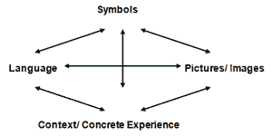Children are introduced to the processes of calculation through practical, oral and mental activities, through a variety of contextual and concrete experiences; employing the connective model (see diagram).

As children begin to understand mathematical ideas they develop ways of recording to support their thinking and calculation methods.

Over time children learn how to use models and images, such as empty number lines, to support their mental and informal written methods of calculation.

When faced with a calculation, children should be able to decide which method is most appropriate and have a range of strategies to check its accuracy. This has to be underpinned by a secure and appropriate knowledge of number facts and mental methods.

**Mental methods of calculation**

Practical, oral and mental work in mathematics is essential in calculation, building on counting strategies and a secure knowledge of place value and number facts. Children need to recognise how the operations relate to one another and should be taught **simultaneously.**

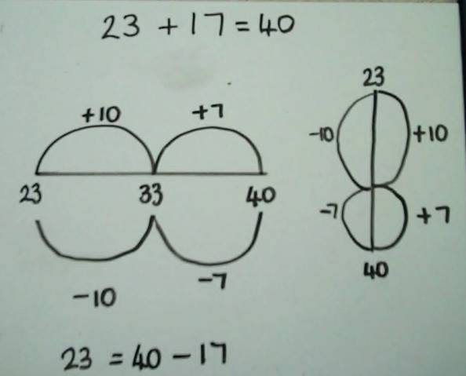 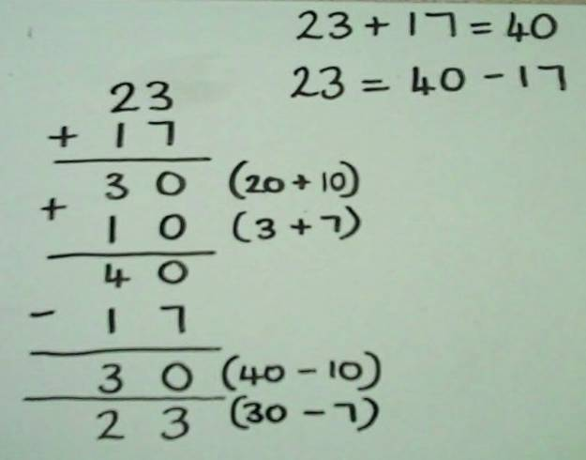

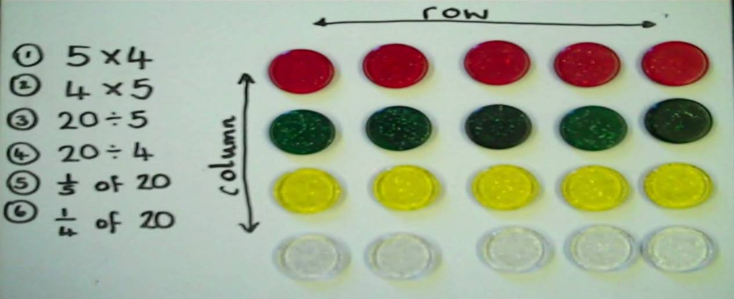

The ability to calculate mentally forms the basis of all methods of calculation and has to be maintained and refined. A good knowledge of numbers or a ‘feel’ for numbers is the product of structured practice and repetition. It requires an understanding of number patterns and relationships developed through directed enquiry, use of models and images and the application of acquired number knowledge and skills.

### Written methods of calculation

The aim is that by the end of Key Stage 2, the great majority of children should be able to use an efficient written method for each operation with confidence and understanding.

**The overall aim is that when children leave primary school they:**

* **have a secure knowledge of number facts and of the four operations**
* **are able to use this knowledge and understanding to carry out calculations mentally and to apply general calculation strategies**
* **make use of diagrams and informal notes to help record stages of calculation**
* **have an efficient, reliable, compact written method of calculation for each operation that they cannot carry out mentally**
* **use a calculator effectively, using their mental skills to monitor the process, check the steps involved and decide if the numbers displayed make sense.**

This guidance promotes the use of what are commonly known as ‘standard’ written methods – methods that are efficient and work for any calculations, to keep track of recorded steps.

In setting out these aims, we intend to adopt greater consistency in our approach to teaching calculation, which all teaching staff can use and understand.

If the long-term aims are shared across the school, and if expectations are consistent then children’s progress should be enhanced.