DISHES AND THEIR ALLERGEN CONTENT – Ventrus – Primary School – Autumn/Winter 2021/22
✓ Contains ✓ May Contain
 | 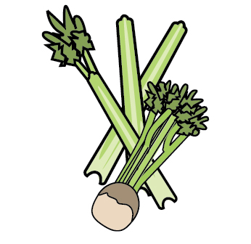 | 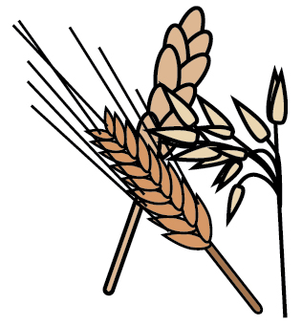 | 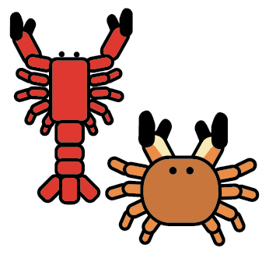 | 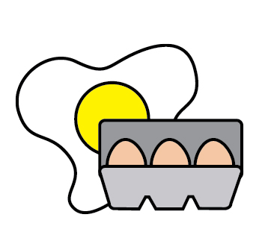 |  | 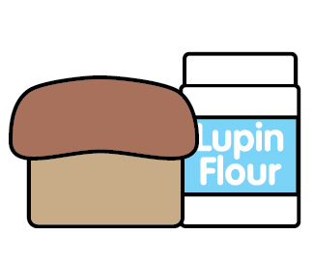 |  |  | 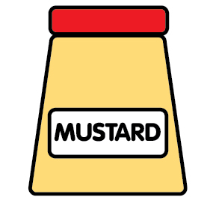 | 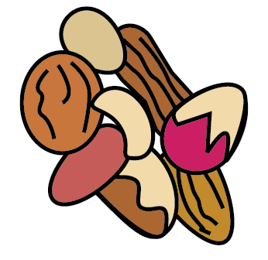 | 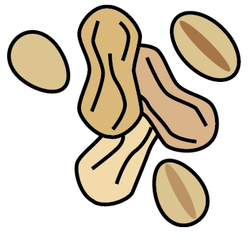 | 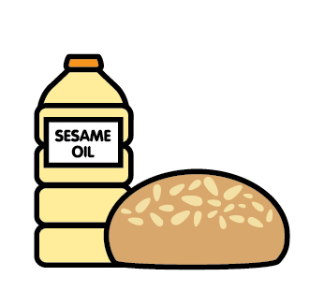
 | Celery | Cereals containing gluten | Crustaceans | Eggs | Fish | Lupin | Milk | Mollusca | Mustard | Nuts | Peanuts | Sesame seeds | Soya | Sulphur Dioxide
Cheese & Ham Pasta Bake |  | ✓ |  | ✓ |  |  | ✓
Butchers Sausage |  |  |  |  |  |  |  |  |  |  |  |  |  | ✓
Roast Chicken
Beef Cobbler |  | ✓ |  | ✓ |  |  | ✓ |  |  |  |  |  | ✓
Fish Finger |  | ✓ |  |  | ✓
Beef Burger |  |  |  |  |  |  |  |  |  |  |  |  |  | ✓
Margherita Pizza |  | ✓ |  | ✓ |  |  | ✓
Ready Made Pizza Base |  | ✓
Packet Mix Pizza Base |  | ✓ |  | ✓ |  |  | ✓ |  |  |  |  |  | ✓
Roast Pork
Chicken Korma |  |  |  |  |  |  |  |  |  |  |  |  |  | ✓
Breaded Fish Fillet |  | ✓ |  |  | ✓
Beef Lasagna |  | ✓ |  |  |  |  | ✓
Chicken & Veg. Pie |  | ✓ |  | ✓
Roast Turkey
Toad in the Hole |  | ✓ |  | ✓ |  |  | ✓
Salmon Fish Cakes |  | ✓ |  |  | ✓
VEGETARIAN
Quorn Sausage |  | ✓ |  | ✓ |  |  | ✓
Sweet & Sour Quorn Pieces |  |  |  | ✓ |  |  |  |  |  |  |  |  |  | ✓
Lentil Loaf | ✓ | ✓ |  | ✓
Veggie Wellington | √ | √ |  | √ |  |  | √ |  | √ |  |  |  | √ | √
Margherita Pizza |  | ✓ |  | ✓ |  |  | ✓
Quorn Vegan Nuggets |  | ✓
Sweet Potato & Lentil Curry
Quorn Chilli | ✓ | ✓ |  | ✓
Veggie Roast | ✓ | ✓ |  | ✓ |  |  | ✓ |  | ✓ |  |  |  | ✓ | ✓
Cauliflower Bites |  | ✓ |  | ✓ |  |  | ✓
Moroccan Cauliflower Bites
Quorn Sausage Roll |  | ✓ |  | ✓ |  |  | ✓
Vegetable Gratin |  |  |  |  |  |  | ✓
Roasted Veg. Bolognaise |  | ✓
Spinach, Red Pepper, Mozzarella Pasta Bake |  | ✓ |  | ✓ |  |  | ✓
PUDDINGS
Chocolate Courgette Cake |  | ✓ |  | ✓ |  |  |  |  |  |  |  |  | ✓
Fruit Smoothie
Banana Cake |  | ✓ |  | ✓ |  |  |  |  |  |  |  |  | ✓
Oatie Cookie |  | ✓ |  |  |  |  |  |  |  |  |  |  | ✓
Sticky Toffee Sponge |  | ✓ |  | ✓ |  |  | ✓ |  |  |  |  |  | ✓
Apple Cake |  | ✓ |  | ✓ |  |  |  |  |  |  |  |  | ✓
Carrot Cake |  | ✓ |  | ✓ |  |  |  |  |  |  |  |  | ✓
Raspberry Cake |  | ✓ |  | ✓ |  |  |  |  |  |  |  |  | ✓
Iced Sponge |  | ✓ |  | ✓ |  |  | ✓ |  |  |  |  |  | ✓
Custard |  |  |  |  |  |  | ✓
SIDES
Cater Choice Gravy
Sautee Potatoes
Pomme Noisette
Chips
Roast Potato
Wedges
Sweet Potato Wedges
Stuffing | ✓ | ✓ |  | ✓ |  |  | ✓ |  | ✓ |  |  |  | ✓ | ✓
Wholemeal Pasta |  | ✓
Country Range Wholegrain Rice
Naan Bread |  | ✓ |  |  |  |  | ✓
Kara Wholemeal Sliced Bread |  | ✓ |  | ✓ |  |  |  |  |  |  |  |  | ✓
Brioche Hot Dog Roll |  | ✓ |  | ✓ |  |  | ✓ |  |  |  |  | ✓
Country Range Floured Bap |  | ✓ |  |  |  |  |  |  |  |  |  | ✓
Tomato Sauce
Baked Beans
Peas
Sweetcorn

