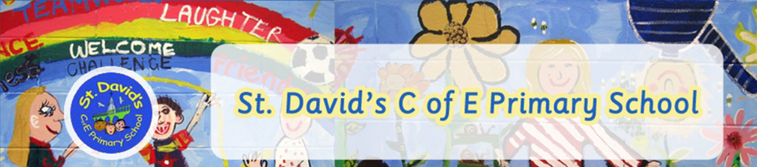
Reading
Year 1

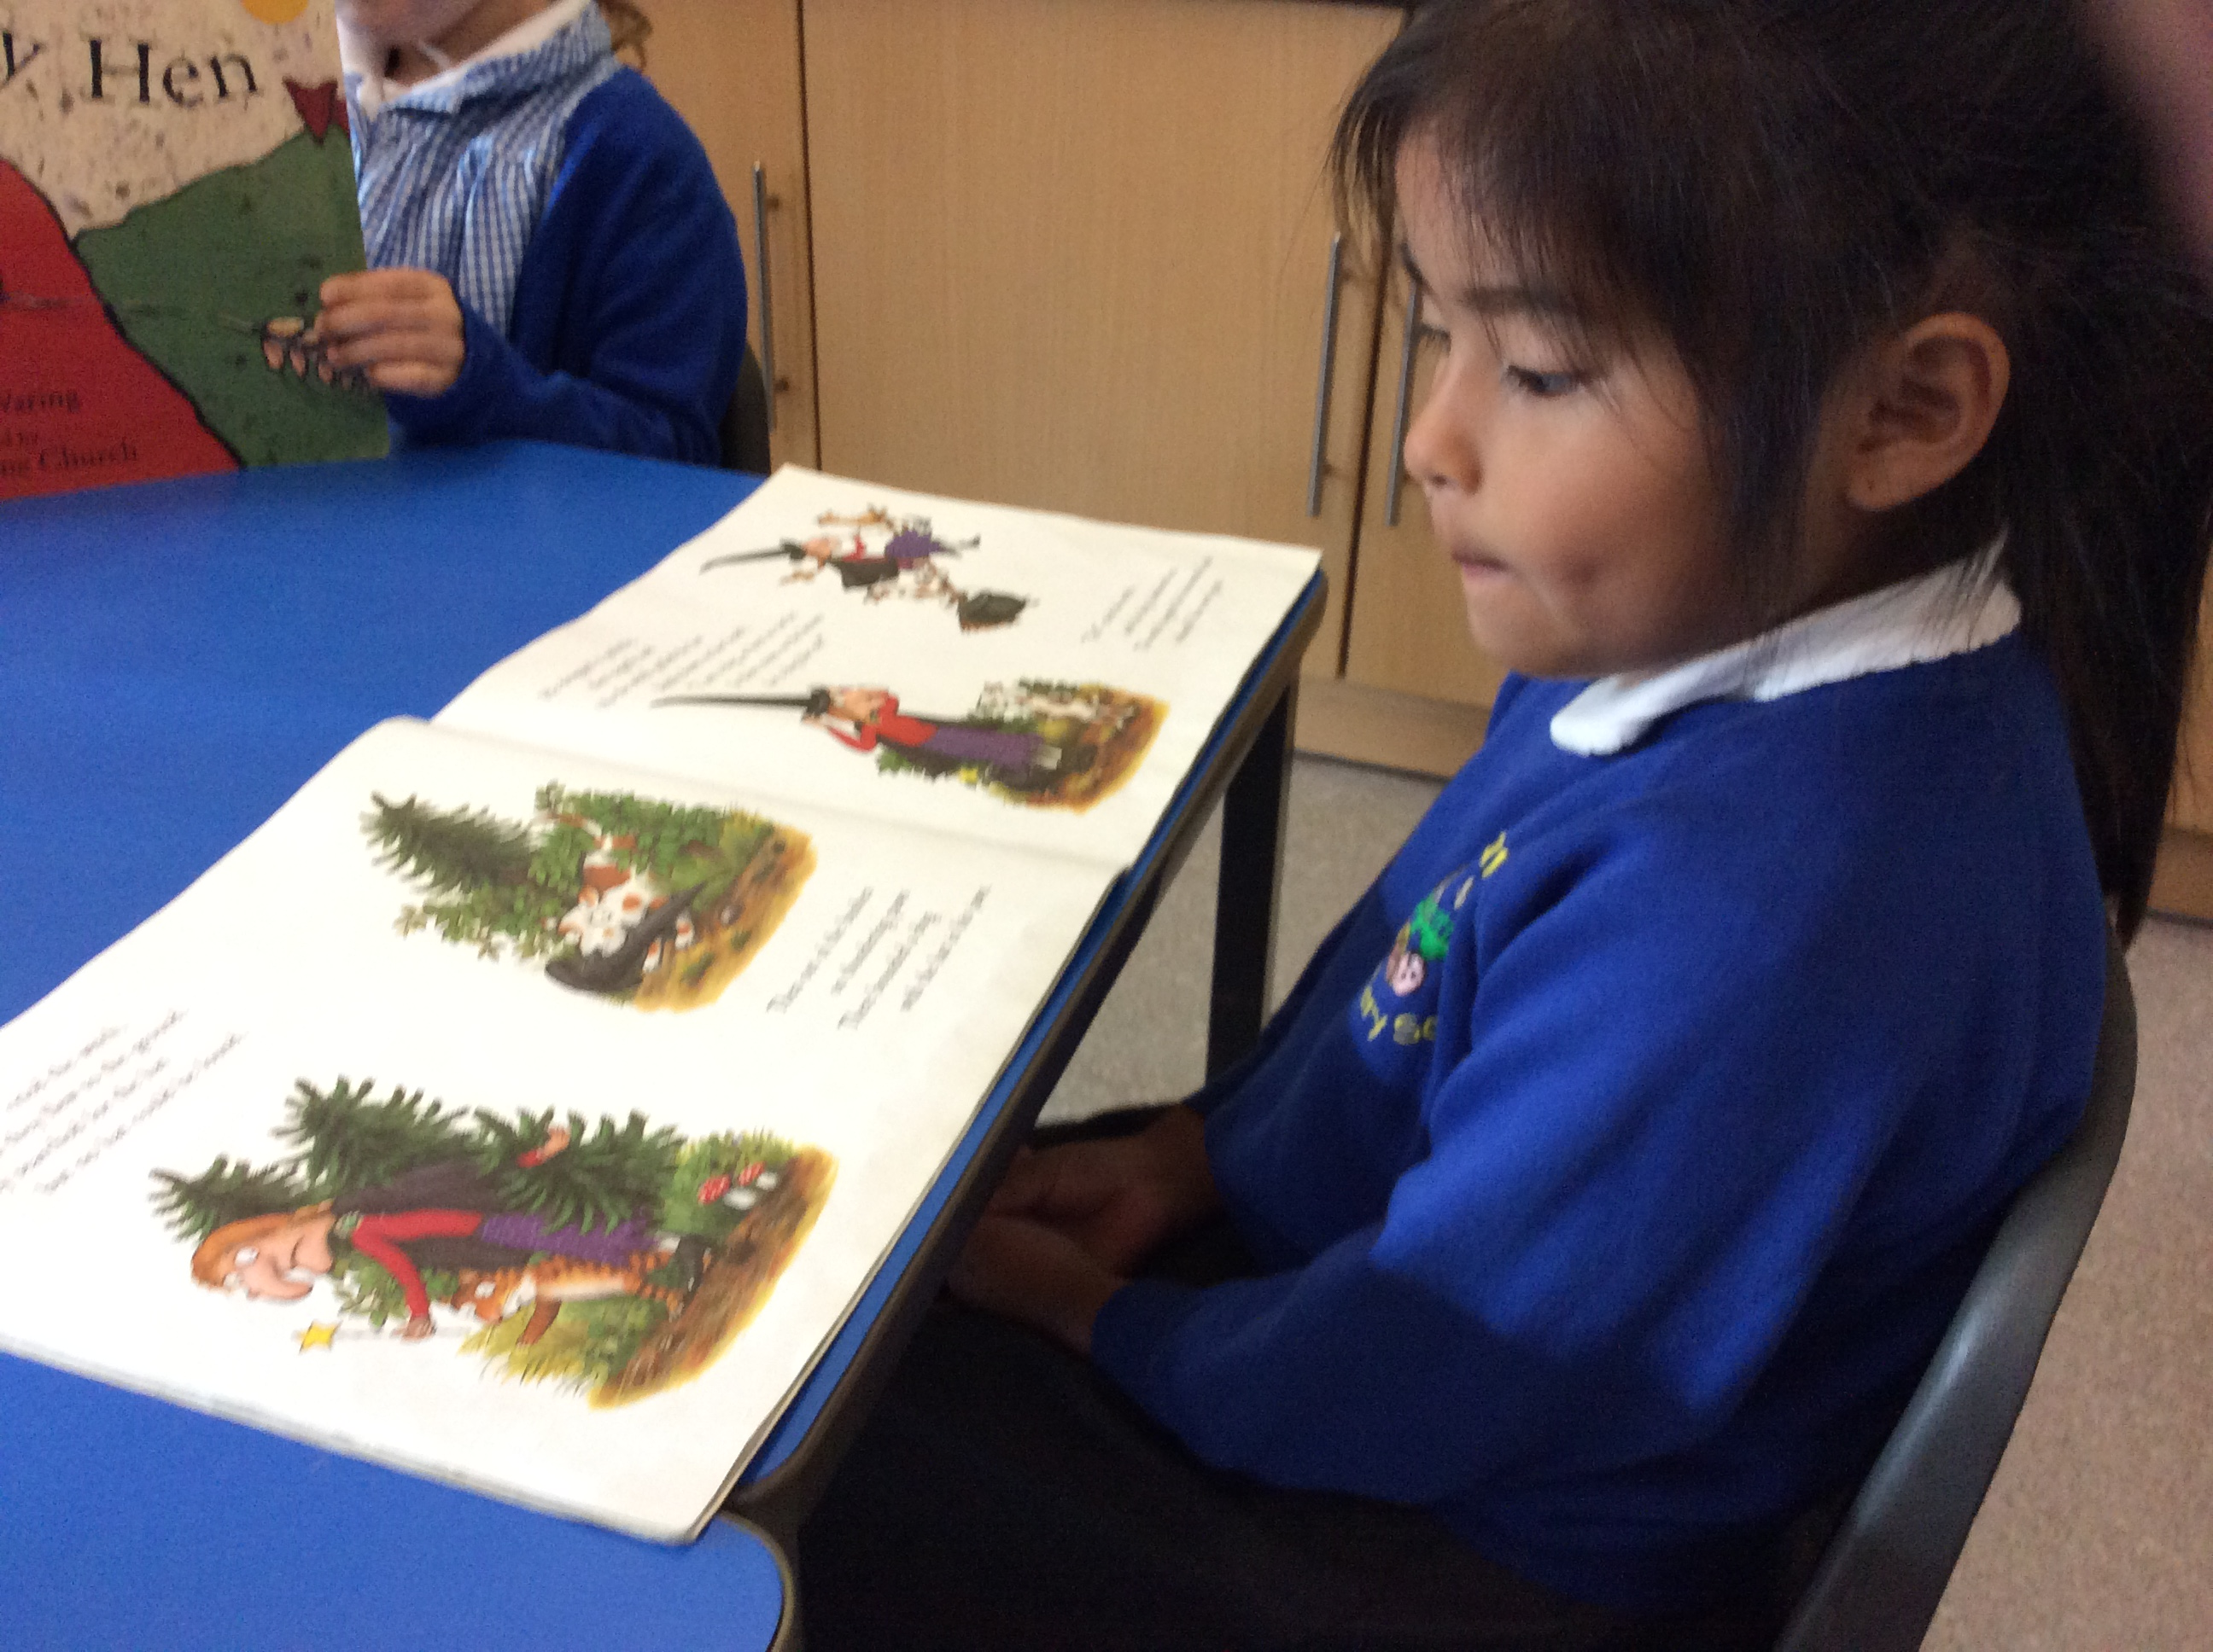

READING Year 1
Strand | Learning Intention: | This is a working document. Teachers will add examples of greater depth throughout the year.
Word | - Apply phonic knowledge and skills as the route to decode words.  - Respond speedily with the correct sound to graphemes (letters or groups of letters) for all 40+ phonemes, including, where applicable, alternative sounds for graphemes.  - Read accurately by blending sounds in unfamiliar words containing GPCs that have been taught.  - Read common exception words, noting unusual correspondences between spelling and sound and where these occur in the word.  - Read words containing taught GPCs and -s, -es, -ing, -ed, -er and -est endings.  - Read other words of more than one syllable that contain taught GPCs.  - Read words with contractions [for example, I'm, I'll, we'll], and understand that the apostrophe represents the omitted letter(s).  - Read aloud accurately books that are consistent with their developing phonic knowledge and that do not require them to use other strategies to work out words.  - Re-read these books to build up their fluency and confidence in word reading.
Comprehension | - Listening to and discussing a wide range of poems, stories and non-fiction at a level beyond that at which they can read independently.  - Being encouraged to link what they read or hear read to their own experiences.  - Becoming very familiar with key stories, fairy stories and traditional tales, retelling them and considering their particular characteristics.  - Recognising and joining in with predictable phrases.  - Learning to appreciate rhymes and poems, and to recite some by heart.  - Discussing word meanings, linking new meanings to those already known.  - Drawing on what they already know or on background information and vocabulary provided by the teacher.  - Checking that the text makes sense to them as they read and correcting inaccurate reading.  - Discussing the significance of the title and events.  - Making inferences on the basis of what is being said and done.  - Predicting what might happen on the basis of what has been read so far.  - Participate in discussion about what is read to them, taking turns and listening to what others say.  - Explain clearly their understanding of what is read to them.

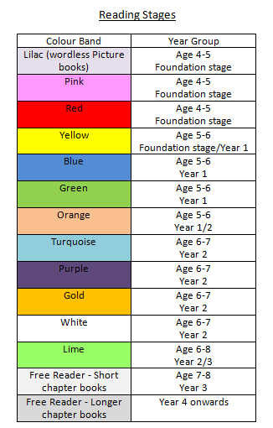

Reading
Year 2

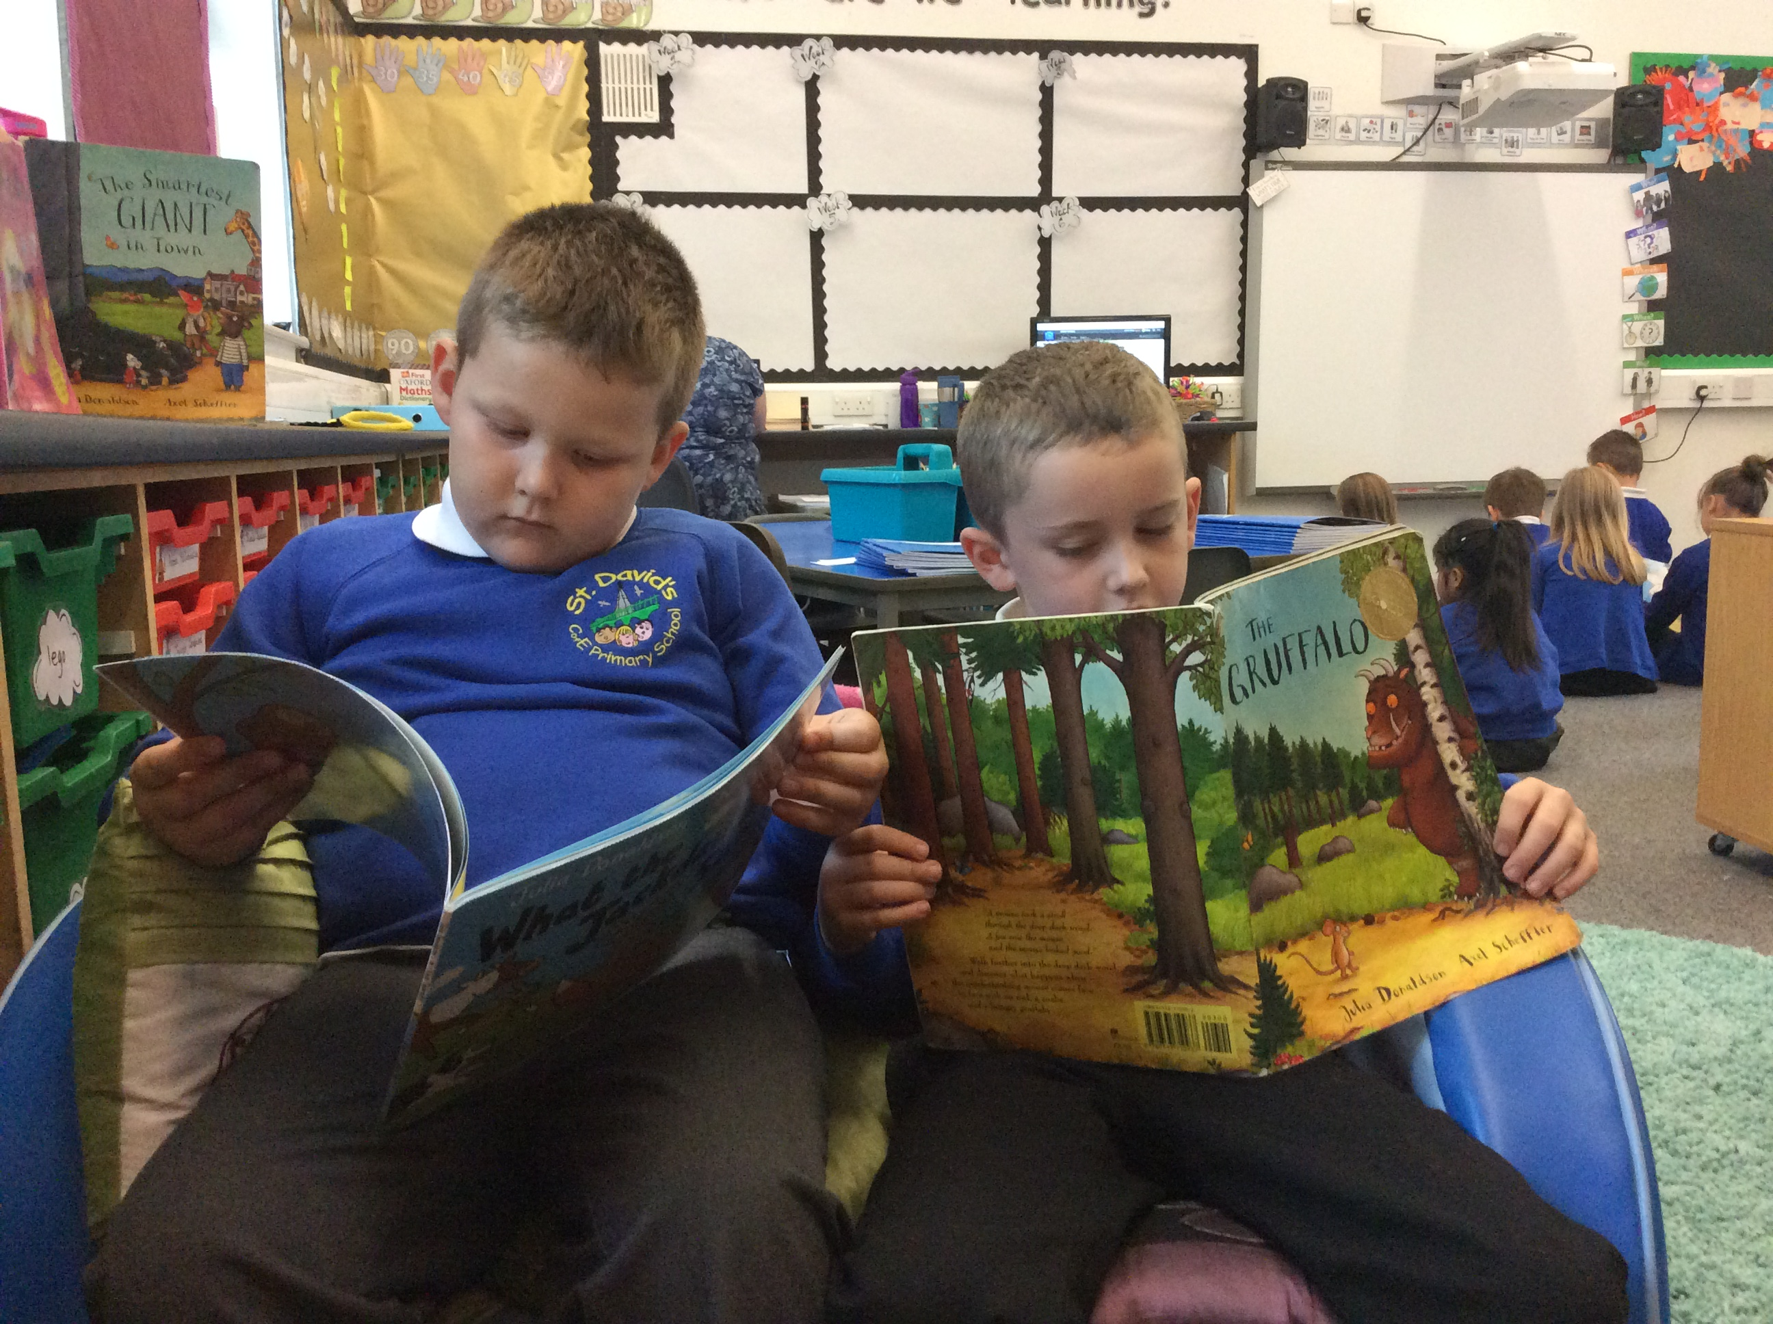

READING Year 2
Strand | Learning Intention: | This is a working document. Teachers will add examples of greater depth throughout the year.
Word | - Continue to apply phonic knowledge and skills as the route to decode words until automatic decoding has become embedded and reading is fluent.  - Read accurately by blending the sounds in words that contain the graphemes taught so far, especially recognising alternative sounds for graphemes.  - Read accurately words of two or more syllables that contain the same graphemes as above.  - Read words containing common suffixes.  - Read further common exception words, noting unusual correspondences between spelling and sound and where these occur in the word.  - Read most words quickly and accurately, without overt sounding and blending, when they have been frequently encountered.  - Read aloud books closely matched to their improving phonic knowledge, sounding out unfamiliar words accurately, automatically and without undue hesitation.  - Re-read these books to build up their fluency and confidence in word reading.
Comprehension | - Listening to, discussing and expressing views about a wide range of contemporary and classic poetry, stories and non-fiction at a level beyond that at which they can read independently.  - Discussing the sequence of events in books and how items of information are related.  - Becoming increasingly familiar with and retelling a wider range of stories, fairy stories and traditional tales.  - Being introduced to non-fiction books that are structured in different ways.  - Recognising simple recurring literary language in stories and poetry.  - Discussing and clarifying the meanings of words, linking new meanings to known vocabulary.  - Discussing their favourite words and phrases.  - Continuing to build up a repertoire of poems learnt by heart, appreciating these and reciting some, with appropriate intonation to make the meaning clear.  - Drawing on what they already know or on background information and vocabulary provided by the teacher.  - Checking that the text makes sense to them as they read and correcting inaccurate reading.  - Making inferences on the basis of what is being said and done.  - Answering and asking questions.  - Predicting what might happen on the basis of what has been read so far.  - Participate in discussion about books, poems and other works that are read to them and those that they can read for themselves, taking turns and listening to what others say.  - Explain and discuss their understanding of books, poems and other material, both those that they listen to and those that they read for themselves.

Reading
Year 3

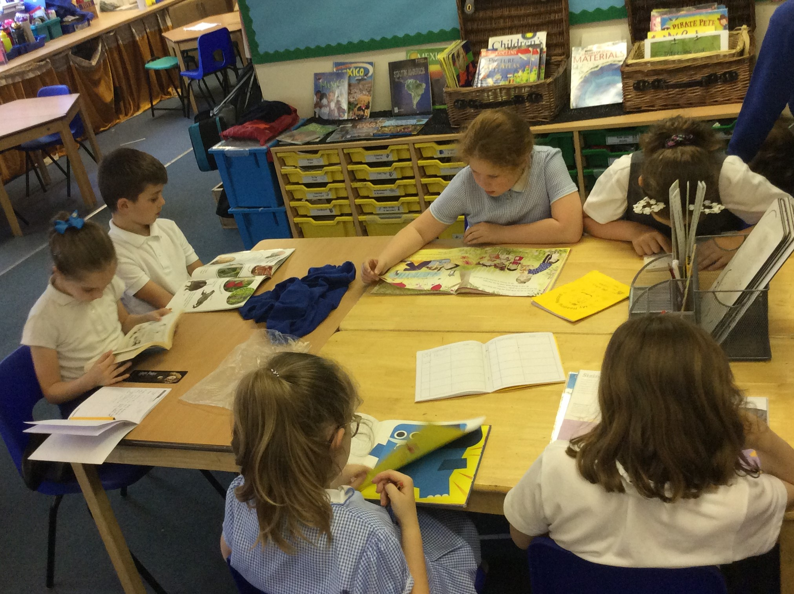

READING Year 3
Strand | Learning Intention: | This is a working document. Teachers will add examples of greater depth throughout the year.
Word | - Apply their growing knowledge of root words, prefixes and suffixes (etymology and morphology) as listed in English Appendix 1, both to read aloud and to understand the meaning of new words they meet.  - Read further exception words, noting the unusual correspondences between spelling and sound, and where these occur in the word.
Comprehension | - Listening to and discussing a wide range of fiction, poetry, plays, non-fiction and reference books or textbooks.  - Reading books that are structured in different ways and reading for a range of purposes.  - Using dictionaries to check the meaning of words that they have read.  - Increasing their familiarity with a wide range of books, including fairy stories, myths and legends, and retelling some of these orally.  - Identifying themes and conventions in a wide range of books.  - Preparing poems and play scripts to read aloud and to perform, showing understanding through intonation, tone, volume and action.  - Discussing words and phrases that capture the reader's interest and imagination.  - Recognising some different forms of poetry [for example, free verse, narrative poetry].  - Checking that the text makes sense to them, discussing their understanding and explaining the meaning of words in context.  - Asking questions to improve their understanding of a text.  - Drawing inferences such as inferring characters' feelings, thoughts and motives from their actions, and justifying inferences with evidence.  - Predicting what might happen from details stated and implied.  - Identifying main ideas drawn from more than one paragraph and summarising these.  - Identifying how language, structure, and presentation contribute to meaning.  - Retrieve and record information from non-fiction.  - Participate in discussion about both books that are read to them and those they can read for themselves, taking turns and listening to what others say.
Reading
Year 4

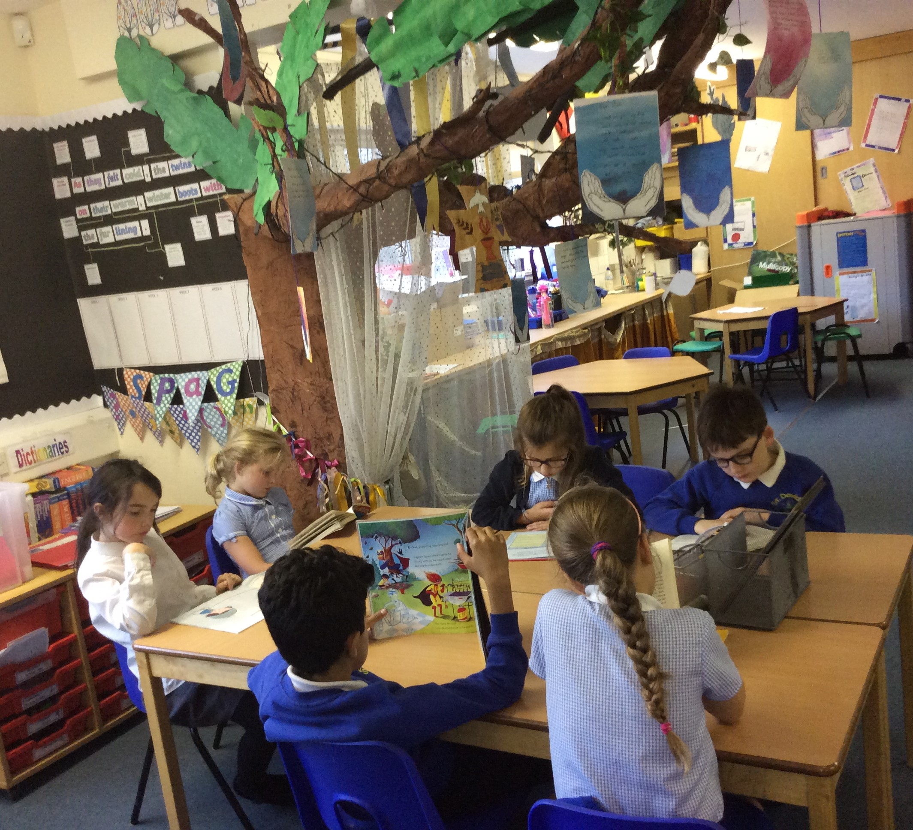

READING Year 4
Strand | Learning Intention: | This is a working document. Teachers will add examples of greater depth throughout the year.
Word | - Apply their growing knowledge of root words, prefixes and suffixes (etymology and morphology) as listed in English Appendix 1, both to read aloud and to understand the meaning of new words they meet.  - Read further exception words, noting the unusual correspondences between spelling and sound, and where these occur in the word.
Comprehension | - Listening to and discussing a wide range of fiction, poetry, plays, non-fiction and reference books or textbooks.  - Reading books that are structured in different ways and reading for a range of purposes.  - Using dictionaries to check the meaning of words that they have read.  - Increasing their familiarity with a wide range of books, including fairy stories, myths and legends, and retelling some of these orally.  - Identifying themes and conventions in a wide range of books.  - Preparing poems and play scripts to read aloud and to perform, showing understanding through intonation, tone, volume and action.  - Discussing words and phrases that capture the reader's interest and imagination.  - Recognising some different forms of poetry [for example, free verse, narrative poetry].  - Checking that the text makes sense to them, discussing their understanding and explaining the meaning of words in context.  - Asking questions to improve their understanding of a text.  - Drawing inferences such as inferring characters' feelings, thoughts and motives from their actions, and justifying inferences with evidence.  - Predicting what might happen from details stated and implied.  - Identifying main ideas drawn from more than one paragraph and summarising these.  - Identifying how language, structure, and presentation contribute to meaning.  - Retrieve and record information from non-fiction.  - Participate in discussion about both books that are read to them and those they can read for themselves, taking turns and listening to what others say.

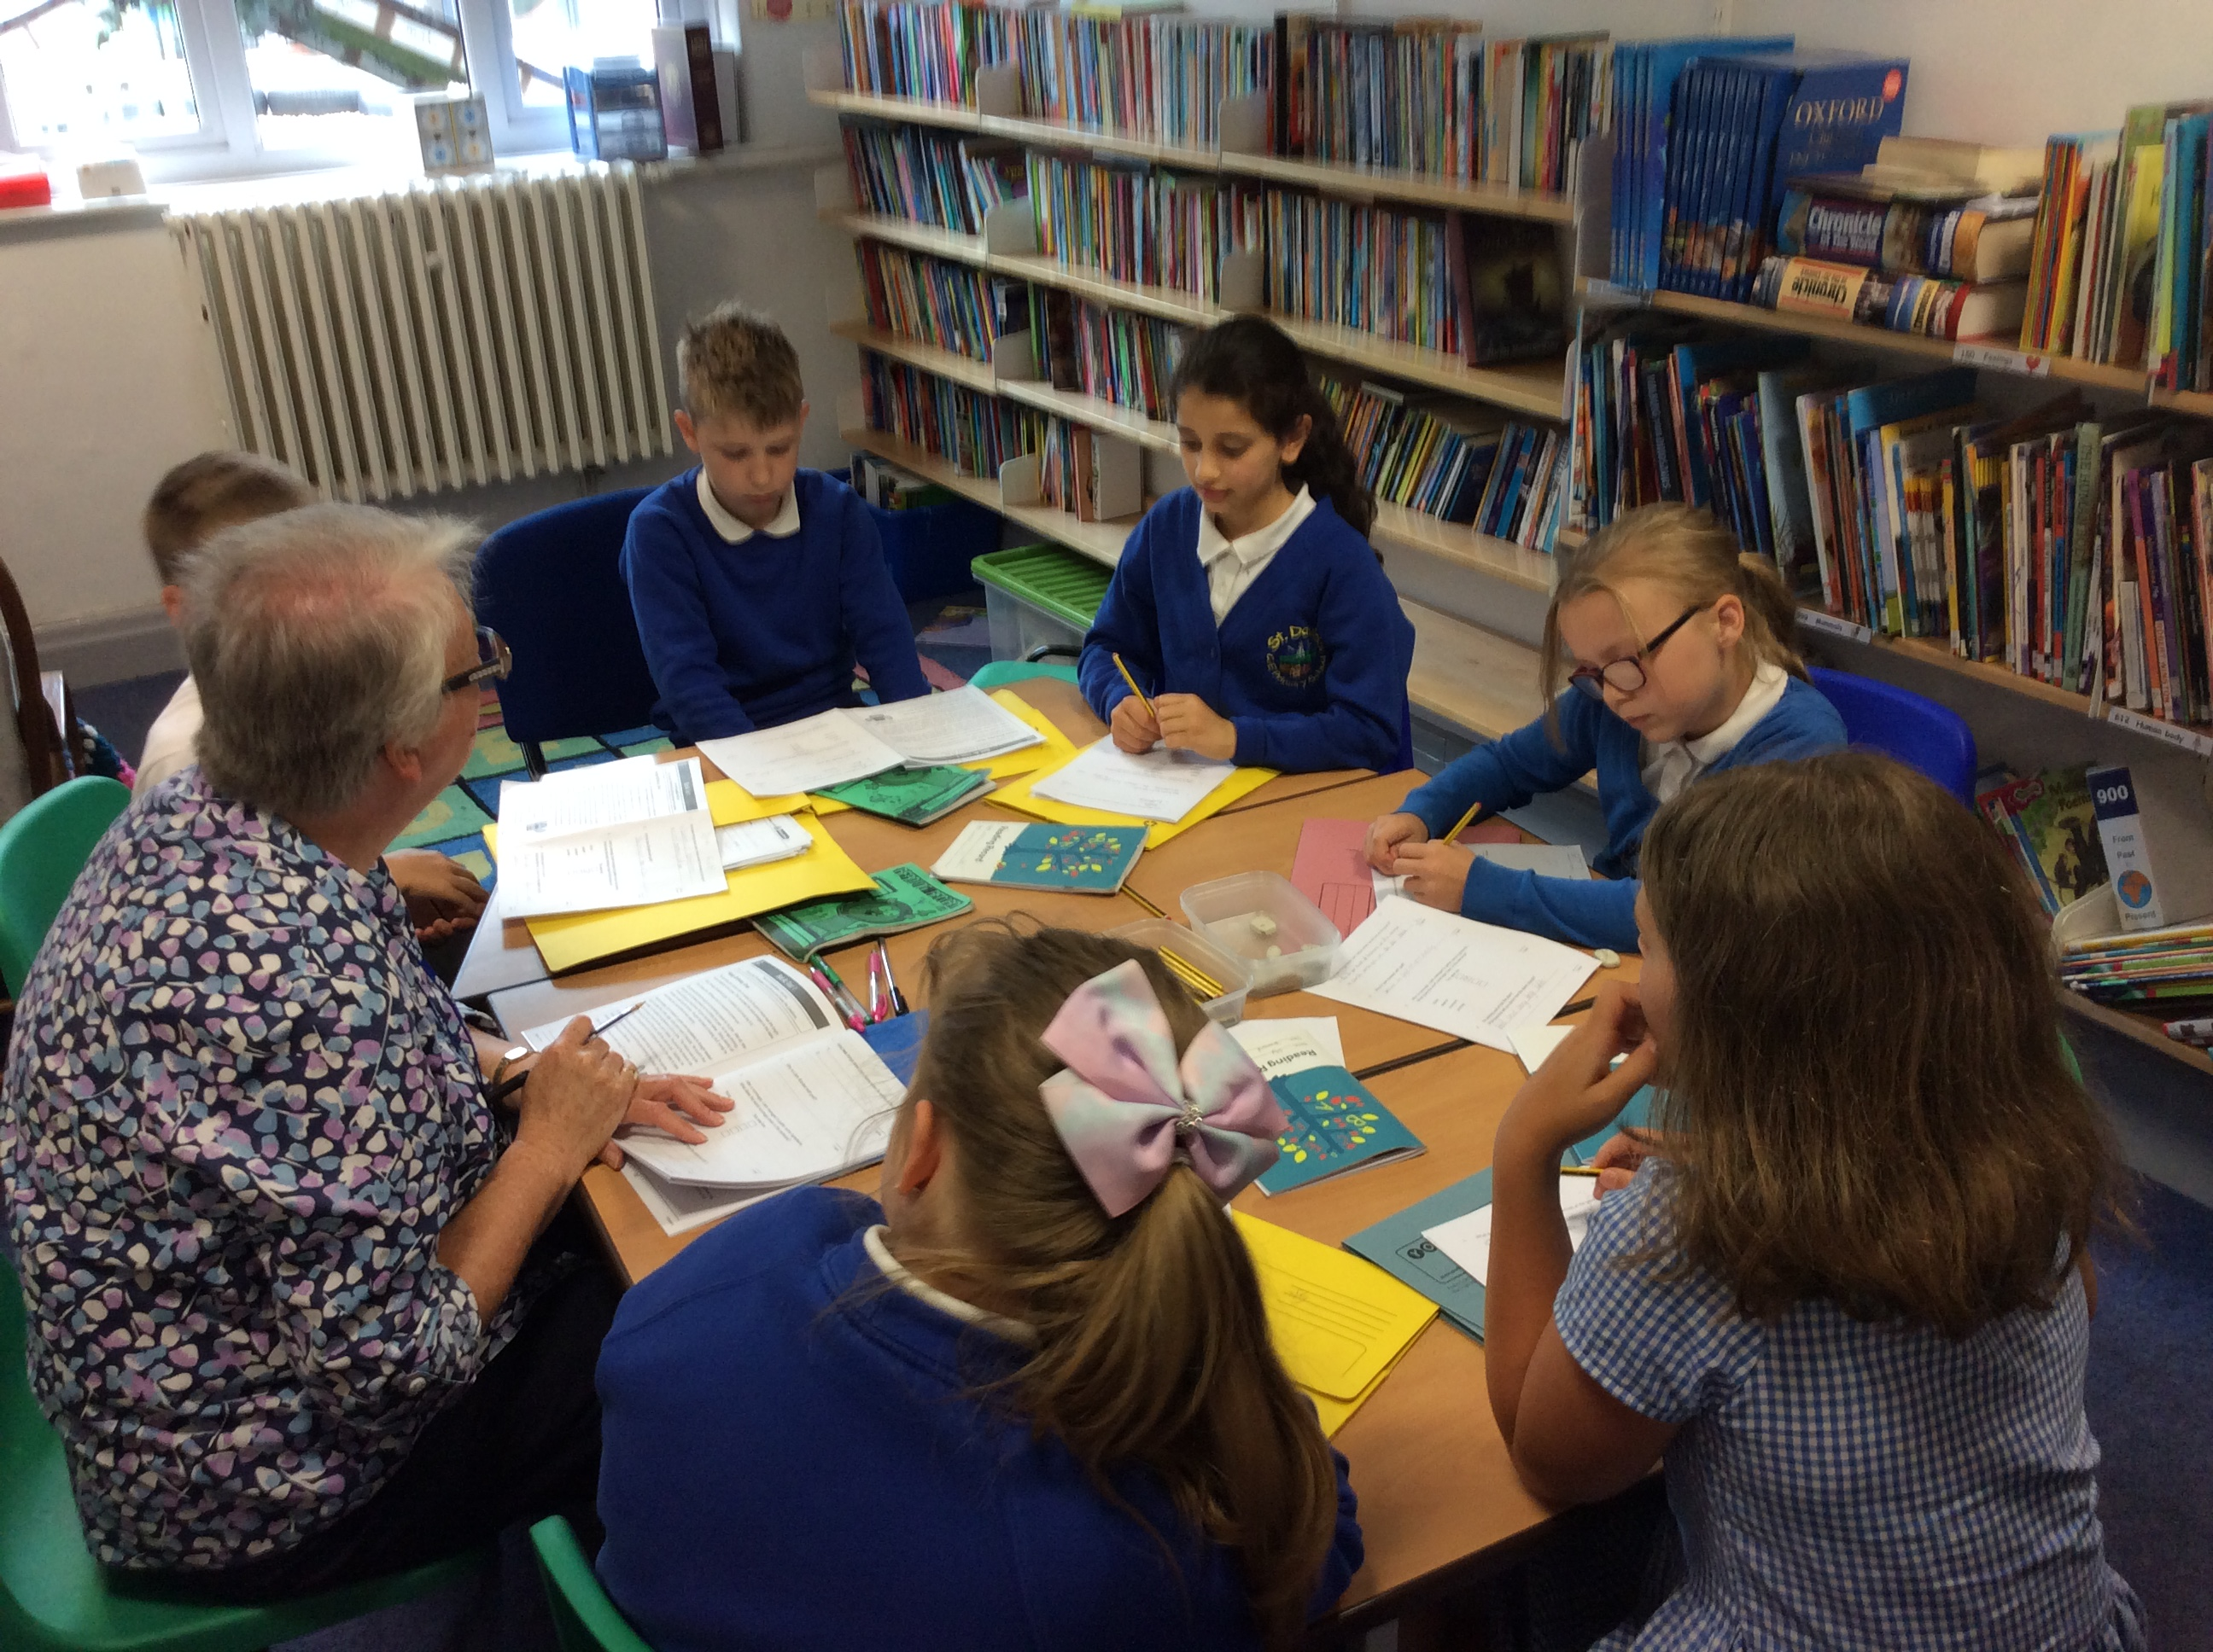
Reading
Year 5

READING Year 5
Strand | Learning Intention: | This is a working document. Teachers will add examples of greater depth throughout the year.
Word | - Apply their growing knowledge of root words, prefixes and suffixes (morphology and etymology), as listed in English Appendix 1, both to read aloud and to understand the meaning of new words that they meet.
Comprehension | - Continuing to read and discuss an increasingly wide range of fiction, poetry, plays, non-fiction and reference books or textbooks.  - Reading books that are structured in different ways and reading for a range of purposes.  - Increasing their familiarity with a wide range of books, including myths, legends and traditional stories, modern fiction, fiction from our literary heritage, and books from other cultures and traditions.  - Recommending books that they have read to their peers, giving reasons for their choices.  - Identifying and discussing themes and conventions in and across a wide range of writing.  - Making comparisons within and across books.  - Learning a wider range of poetry by heart.  - Preparing poems and plays to read aloud and to perform, showing understanding through intonation, tone and volume so that the meaning is clear to an audience.  - Checking that the book makes sense to them, discussing their understanding and exploring the meaning of words in context.  - Asking questions to improve their understanding.  - Drawing inferences such as inferring characters' feelings, thoughts and motives from their actions, and justifying inferences with evidence.  - Predicting what might happen from details stated and implied.  - Summarising the main ideas drawn from more than one paragraph, identifying key details that support the main ideas.  - Identifying how language, structure and presentation contribute to meaning.  - Discuss and evaluate how authors use language, including figurative language, considering the impact on the reader.  - Distinguish between statements of fact and opinion.  - Retrieve, record and present information from non-fiction.  - Participate in discussions about books that are read to them and those they can read for themselves, building on their own and others' ideas and challenging views courteously.  - Explain and discuss their understanding of what they have read, including through formal presentations and debates, maintaining a focus on the topic and using notes where necessary.  - Provide reasoned justifications for their views.

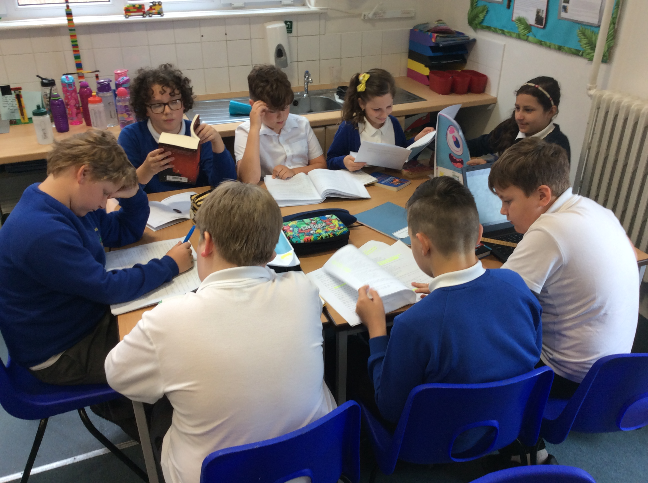
Reading
Year 6

READING Year 6
Strand | Learning Intention: | This is a working document. Teachers will add examples of greater depth throughout the year.
Word | - Apply their growing knowledge of root words, prefixes and suffixes (morphology and etymology), as listed in English Appendix 1, both to read aloud and to understand the meaning of new words that they meet.
Comprehension | - Continuing to read and discuss an increasingly wide range of fiction, poetry, plays, non-fiction and reference books or textbooks.  - Reading books that are structured in different ways and reading for a range of purposes.  - Increasing their familiarity with a wide range of books, including myths, legends and traditional stories, modern fiction, fiction from our literary heritage, and books from other cultures and traditions.  - Recommending books that they have read to their peers, giving reasons for their choices.  - Identifying and discussing themes and conventions in and across a wide range of writing.  - Making comparisons within and across books.  - Learning a wider range of poetry by heart.  - Preparing poems and plays to read aloud and to perform, showing understanding through intonation, tone and volume so that the meaning is clear to an audience.  - Checking that the book makes sense to them, discussing their understanding and exploring the meaning of words in context.  - Asking questions to improve their understanding.  - Drawing inferences such as inferring characters' feelings, thoughts and motives from their actions, and justifying inferences with evidence.  - Predicting what might happen from details stated and implied.  - Summarising the main ideas drawn from more than one paragraph, identifying key details that support the main ideas.  - Identifying how language, structure and presentation contribute to meaning.  - Discuss and evaluate how authors use language, including figurative language, considering the impact on the reader.  - Distinguish between statements of fact and opinion.  - Retrieve, record and present information from non-fiction.  - Participate in discussions about books that are read to them and those they can read for themselves, building on their own and others' ideas and challenging views courteously.  - Explain and discuss their understanding of what they have read, including through formal presentations and debates, maintaining a focus on the topic and using notes where necessary.  - Provide reasoned justifications for their views.

