 | Addition To be taught alongside each other Subtraction |  | Multiplication To be taught alongside each other Division
Y6  Y7 | Children should:  - add several numbers with different numbers of digits;  - begin to add two or more decimal fractions with up to four digits and either one or two decimal places;  - know that decimal points should line up under each other, particularly when adding or subtracting mixed amounts, e.g. 401.2 + 26.85 + 0.71.  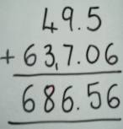  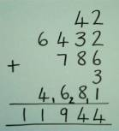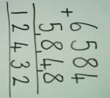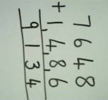  Encourage self checking by writing the inverse calculation below the sum to check immediately.  7 16  8 10 12 14  9 1 3 4  - 1 4 8 6  7 6 4 8  686.56  - 637.06  049.50 | Children should:  - be able to subtract numbers with different numbers of digits;  - be able to subtract two or more decimal fractions with up to three digits and either one or two decimal places;  - know that decimal points should line up under each other.  Number lines ‘Find the difference by counting up’  Where the numbers are involved in the calculation are close together or near to multiples of 10, 100 etc counting on using a number line should be used. E.g. 3002 – 1997 = 1005  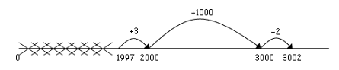  Partitioning leading to decomposition (See Y5) Only when fully secure in using number lines.  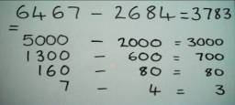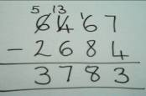  Decomposition (only when secure in using expanded form)  5 1316 5000 1300 160  6467 6000 400 60 7  -2684 - 2000 600 80 4  3783 3000 700 80 3  3783  2684 +  1 1  6467 Self check using inverse.  Negative Column Subtraction (optional) | Short multiplication (by a single digit) – Grid method, Expanded and contracted method (3 and 4 digit x 1 and 2 digit numbers)  4346 x 8  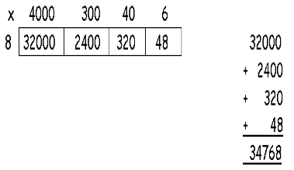  Children will approximate first.  372 x 24 is approximately 400 x 25 = 10000  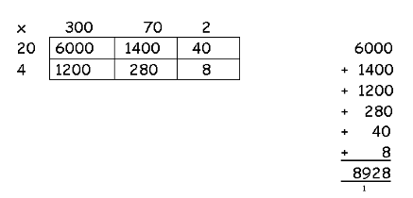  Using similar methods, they will be able to multiply decimals with up to two decimal places by a single digit number and then two digit numbers, approximating first. They should know that the decimal points line up under each other.  4.92 x 3 is approximately 5 x 3 = 15  12  2.7  +0.06  14.76  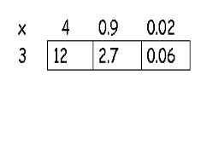  Both Expanded and Contracted methods to be used only when children are confident with the Grid method.  More able children who are confident in all methods encouraged to use alternative methods such as the Lattice method. (ECC)  BODMAS- (brackets over division, multiplication, addition, subtraction) | Children will continue to use written methods to solve short division (division by a single digit)  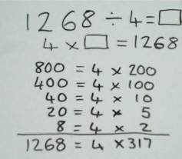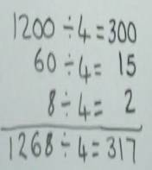  Solve divisions with 3 and 4 digit numbers ÷ 1 and 2 digit numbers.  Continue to use informal jottings on an empty number line to show chunking. E.g. 972 ÷ 36 = 27 36 x 27 = 972  36 x 20 = 720 36 x 5 = 180 36 x 2 = 72  Long division (3 digit ÷ 2 digit)  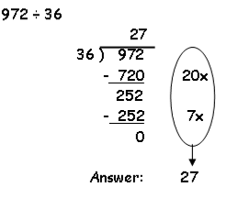  Any remainders should be shown as fractions, i.e. if the children were dividing 32 by 10, the answer should be shown as 3 ²/₁₀ which could then be written as 3 ¹/₅ in it’s lowest terms.  Extend to decimals with up to two decimal places. Children should know that decimal points line up under each other.  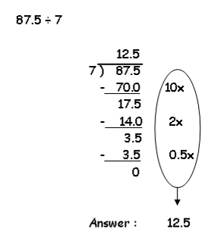  ECC children to be secure with finding fractions using division methods.  BODMAS- (brackets over division, multiplication, addition, subtraction)

