DISHES AND THEIR ALLERGEN CONTENT – Ventrus – Primary School – Summer Menu 2021

✓ Contains ✓ May Contain

DISHES | 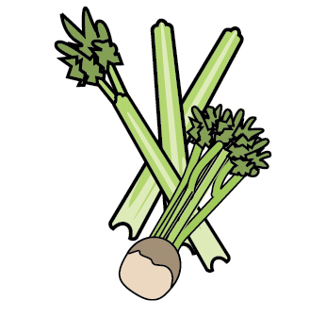 | 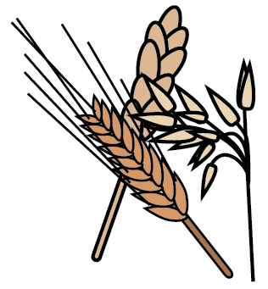 | 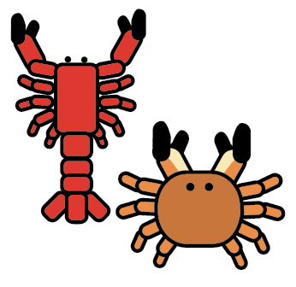 | 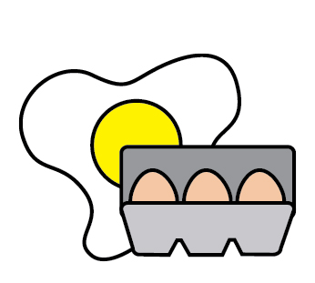 | 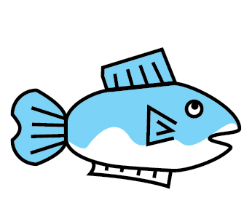 |  |  |  | 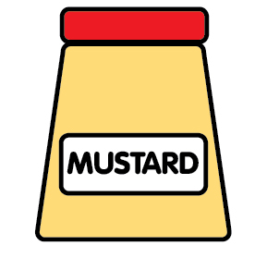 | 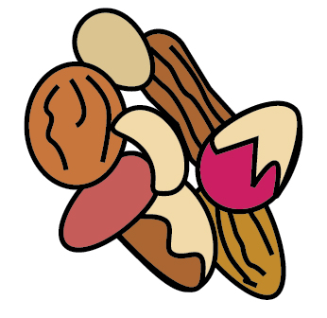 | 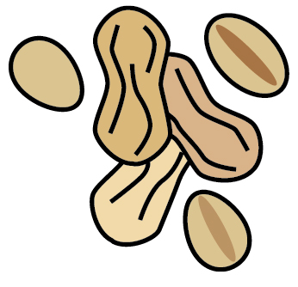 | 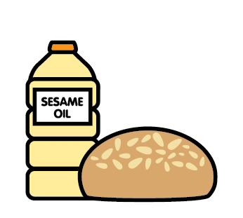 |  | 
 | Celery | Cereals containing gluten | Crustaceans | Eggs | Fish | Lupin | Milk | Mollusc | Mustard | Nuts | Peanuts | Sesame seeds | Soya | Sulphur Dioxide
Ham Carbonara sauce |  |  |  |  |  |  | ✓
Pizza |  | ✓ |  |  |  |  | ✓
Roast Chicken
Crispy Chicken Goujons |  | ✓
Gravy
Beef bolognaise sauce
Breaded Fish |  | ✓ |  |  | ✓
Macaroni Cheese |  | ✓ |  |  |  |  | ✓
Bacon
Sausages |  | ✓ |  |  |  |  |  |  |  |  |  |  |  | ✓
Hot dog Rolls |  | ✓ |  |  |  |  |  |  |  |  |  | ✓
Shepherd’s Pie
Quorn sausages |  | ✓ |  | ✓ |  |  | ✓
Hot Dog Rolls |  | ✓ |  |  |  |  |  |  |  |  |  | ✓
Butternut squash risotto |  |  |  |  |  |  | ✓
Cauliflower and broccoli bake |  |  |  |  |  |  | ✓
Quorn Vegan Nuggets |  | ✓
Haloumi stuffed peppers |  |  |  |  |  |  | ✓
Quorn Chilli |  | ✓ |  | ✓
Sweetcorn and courgette fritters |  | ✓ |  | ✓ |  |  | ✓
Vegetarian Wellington |  | ✓ |  |  |  |  | ✓
Vegetable bolognaise
Jacket Potato
Cheese |  |  |  |  |  |  | ✓
Beans
Tuna |  |  |  |  | ✓
Tuna Mayo |  |  |  |  | ✓
Pasta Pot |  | ✓
Pasta pot with Tuna |  | ✓ |  |  | ✓
Pasta pot with Cheese |  | ✓ |  |  |  |  | ✓
Pasta pot with Ham |  | ✓
Chicken salad
Chicken and Bacon salad
Crispy chicken salad |  | ✓
Sausage roll |  | ✓ |  |  |  |  | ✓
Wedges
Pommes noisettes
Roast potatoes
Chips
Sauté Potato
Pasta
Foccacia Bread |  | ✓
Tomato Ketchup
Rice and peas
Fresh Fruit
Banana and Raspberry cake |  | ✓ |  | ✓
Fruit Smoothie
Apple Cake |  | ✓ |  | ✓
Cookies |  | ✓
Flap Jack |  | ✓
St Clements Sponge |  | ✓ |  | ✓ |  |  |  |  |  |  |  |  |  | ✓

