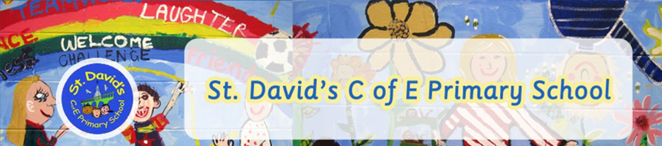
Phonics
(Letters & Sounds)
Year R,1 & 2

PHASE 1 | Aspect 1-General sound discrimination - environmental  Aspect 2-General sound discrimination - instrumental sounds  Aspect 3- General sound discrimination - body percussion  Aspect 4-Rhythm and Rhyme  Aspect 5-Alliteration  Aspect 6-Voice sounds  Aspect 7-Oral blending and segmenting
PHASE 2 | Set 1: s,a,t,p  Set 2: i,n,m,d  Set 3: g,o,c,k  Set 4: ck,e,u,r  Set 5: h,b,f,ff,l,ll,ss
PHASE 3 | Set 6: j,v,w,x  Set 7: y,z,zz,qu  Consonant digraphs: ch,sh,th,ng  Vowel digraphs: ai,ee,oa,oo,ar,or,ow, oi, ear, air,ure,er
PHASE 4 | Practise recognition and recall of Phase 2 and 3 graphemes and reading and spelling CVC words.  Teach and practise reading CVCC words.  Teach and practise spelling CVCC words.  Teach reading tricky words.  Practise reading and spelling High Frequency words.  Practise reading sentences.  Practise writing sentences.
PHASE 5 | ay, ou,ie,ea,oy,ir,ue,aw,wh,ph,ew,oe,au,a-e,e-e,i-e,o-e,u-e,igh,  Common alternative pronunciations:  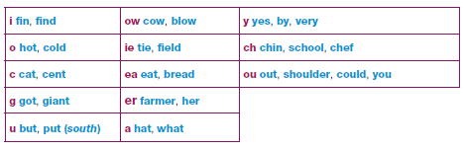  Alternative spellings for phonemes:  